**Autumn Term: Topic ideas relating to theme**

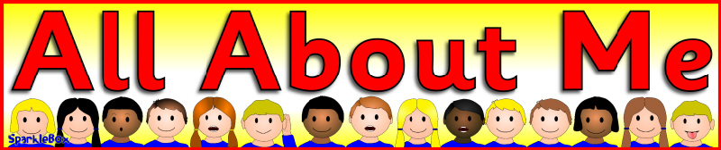**Possible areas for exploration.**

**My School:** places in my school, people in my school, school routines and rules. The school day, celebration assemblies

**My home**: what does it look like, where do I live, people live in different types of homes. If I get lost

**My family**: who is in my family, how many people in my family, all families are different, grandparents day, oldest, youngest, new baby

**My celebrations**: Harvest, Bonfire night, Divali, Eid, Hanuka, Christmas. Any others celebrated by the children and their families, encourage children and parents to share these with us.

**My Pets:** who has what, how do we look after a pet. What do they need? If I could choose a pet, I would have a...

**My favourite things**

My likes/dislikes, we all have different likes/dislikes. My views and feelings.

**My Environment**: looking after it, how can it be improved likes/dislikes. Planting bulbs, flowers etc, decorating the areas with collaborative art work

**My Future:** I can learn new things, I need to practise and persevere to learn new things, when I grow I want to be a... occupational visitors eg parents/ local people

**My History**: talk about past events... a holiday, my birthday, a day out, what I did at the weekend etc. How have I changed baby to now? Celebrations around my birth, eg. Christening, baby welcoming etc

**Important people** to me

People who help me, doctor, dentist, optician, emergency services

**I am Special** we are all different, we look different, we all have different needs, views and feelings, I can do things for myself, I can ask for help when I need it. In what ways are we the same? Eg. Shared interests, views feelings

**My Friends**: Making new friends, Getting on and falling out, sharing/ taking turns, helping each other. Including others in my play.

**My Class**: Classroom rules

Rights and Responsibilities, routines, where is everything kept, what can I use, independence in environment

**My Body**: name parts, what can my body do? My five Senses, keeping healthy

