**Term 2: Detectives**

**History: Pre Roman Britain – Stone Age to Iron Age**

As history detectives we will be asking many questions about Pre-Roman Britain and will be trying to uncover the answers using a range of clues and sources of evidence. Our fact finding missions will include: When were the Stone, Bronze and Iron ages and where are they placed in history? What was life like for people at these times? What food was available? If they had to hunt, what sort of animals did they look for? How did people communicate and how is this different from the way we communicate with one another? How did life change as people became more creative and innovative?

**Geography**: Linking strongly with history, we will ask questions about the key places of archaeological interest for the Stone Age. Why were certain places more preferable than others? We will consider the role of archaeologists as history detectives. What kinds of clues have they found in these key areas? How do they use these clues to create facts?

**Science**

**Rocks**

We will be Rock detectives this term. We will be studying their properties and deciding which rocks are best suited to different purposes. We will be investigating which rocks are hardest and which are waterproof and improving our investigative skills. We will also study fossils and how they are formed. Our detective skills will come in useful to help us understand what these can tell us about the post.

**Light**

We will learn about the importance of light for sight, investigate how mirrors work and how shadows are formed including how we can change the shape and size of a shadow. We will explore this further in art, exploring silhouettes for cave art.

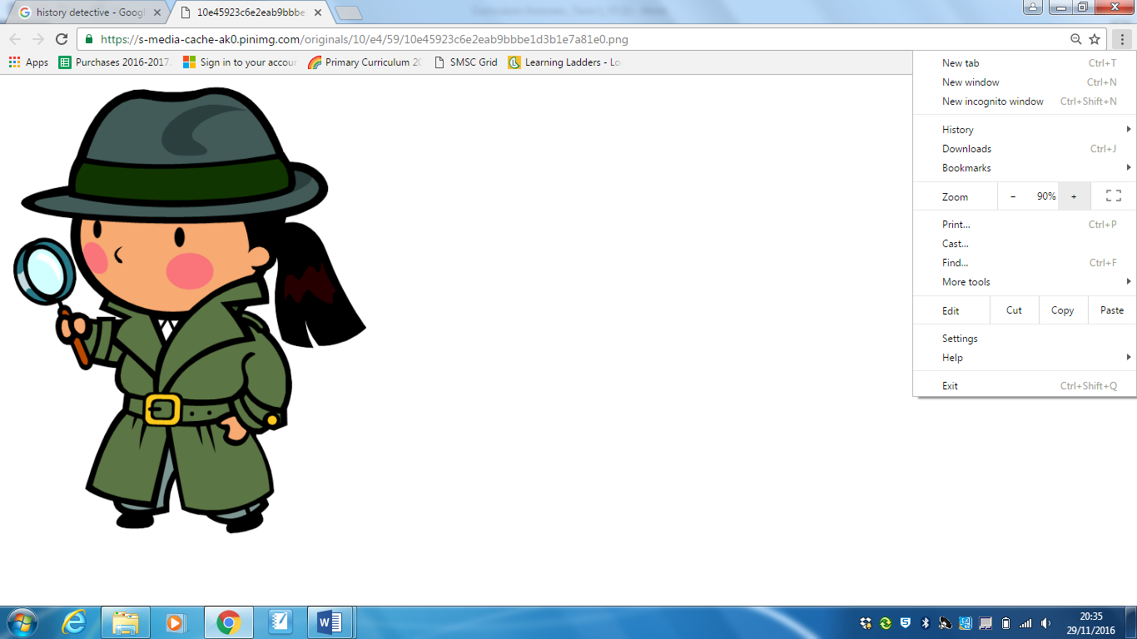

**DT: Stone Age Pots**

We will learn about Neolithic pots found at various sites around the country. We will learn techniques for clay work and aim to design and create a functional pot with traditional geometric engravings.

**Art - Cave Art**

How did Stone Age people create art using limited materials and what does this art tell us about life at that time? We will aim to explore a range of materials and tools to help us recreate cave art linking to shadows work in science.

**PSHE:** Our PSHE will be closely linked to the wellbeing classes we will be taking part in led by Prana Mind. We will focus on physical exercises, breathing and relaxation techniques.

**Computing**:

Being history detectives will require the children to develop their research skills online. They will learn to present their research in the form of posters and presentations developing their word processing skills. We will continue to develop coding skills using Purple Mash.

**RE:**  In RE we will be comparing how religions recognise and celebrate marriage and the family.

**Languages:** In French we will continue to learn our numbers to 20 as well as how to say how old we are. We will also look at colours.

**Music**: Cello lessons will continue for the first four weeks after Christmas. We will then be looking at a variety of songs, listening and appraising them, singing and creating music using the instruments.

**PE**: The children will now focus on **football** skills when working outdoors. They will also have the opportunity to develop their gymnastic and dance movements during indoor PE sessions.