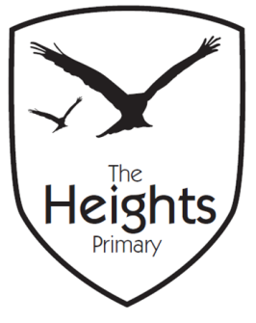

The Heights Primary School
Year 2 Parent Planner: Summer 2 Week 2
Dear Parents/Carers
This term our theme is Pirates.
This week we will be:
English | This week we are learning a new story called ‘Something Fishy’ in which a young girl notices something strange in her washing machine. We will be learning the actions to the story as well as act out the story to show the other class. In Grammar this week we will be looking at how to write exclamatory sentences.
Maths | This week we will be focussing on division. We will start by recapping how to divide using grouping. Later on in the week we will be comparing multiplication number with division number stories and see what patterns we can see. By the end of the week we will be starting to use mental strategies to work out division problems.
Topic | This week in our afternoon sessions we will be writing a non-chronological report about pirates. We will start by looking at one together and then the children will research their own pirate and write a report about them.
Recorders | Mrs Mullaney will be starting to teach recorders this week to the children. If you have purchased one for your child please ensure they have it with them every day.

The children in Year 2 have now started the Cracking Times Tables scheme. Every Monday they will have three minutes to answer times table questions. Each child should know exactly which tables they need to practise at home during the week. Help at home with this will enable them to be successful.

Please support your child by encouraging them to read at home every night. It is extremely important to ask them lots of questions and ensure they understand the meanings of unfamiliar words. Please record this in their record books that are collected in every day. If you have any questions about how to help your child with their learning please see your child’s teacher.

Best wishes,
Miss Kennedy and Mrs Mullaney

