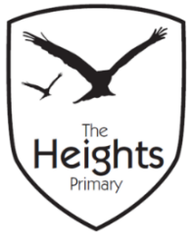

The Heights Primary School
Key Stage Two Parent Planner: Summer 2 Week 3
Dear Parents/Carers,
This term our theme is: Super Structures
This week we will be:
English | This week we will continue learning about persuasion. We will be finishing our adverts from last week and following this, we will begin to look at the features of more formal persuasive writing using these in our own persuasive letter.
Mathematics | This week we will be looking at number sequences and counting on and back from given numbers using steps of a specific size. We will also be looking at 4-digit numbers and applying our knowledge of place value to read and understand them.
Topic | Following our visit to the wind turbine, we are going to be planning how we can build our own turbines in DT. We will also be looking at the structures of various bridges around the world and we will be working in teams to build the strongest bridge using paper!
Thank you to both parents who helped us travel to and from the rounders fixture last week. We really do appreciate this support and wouldn’t be able to do these exciting things without you! Many thanks also for the prompt payments for the travel costs to the turbine.
Our end of year trip to the Earth Trust is coming up on Monday 3rd July. We are so excited to be participating in a Survival Day. Full details can be found on the separate Parentmail. We would like to remind parents that a voluntary contribution of £22 is recommended for this trip. Payment can be made via ParentPay. Thank you in advance for your support!
Over the next few weeks the children will be building their own Wind Turbines. We are going to be in need of resources such as boxes, tubes, paper cups and straws over the coming weeks in order to build our designs. Please ask your child what they might need – it would be great if they could start bringing in their resources in a named bag. Thank you!
Please remember to bring recorders on Wednesday! Best wishes,
Mrs Sanigar and Mrs Wells

