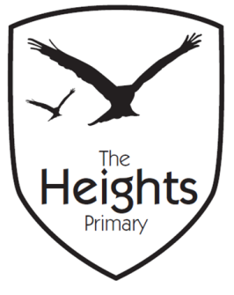

The Heights Primary School
Year 4 Parent Planner: Autumn 1 Week 3
Dear Parents/Carers
We have had a fabulous start to the year. The children have been enjoying the new classrooms and outdoor spaces and have settled back to school life very quickly.
This week our theme is Guatemala

English | The children have recently written autobiographies and following on from this will now be writing biographies of the BFG. They will be encouraged to use their imagination to ‘make up’ a background story for the BFG. We have talked about the fact that real authors would not be allowed to ‘make things up’ when writing a biography. The children will continue to work on their joined handwriting and extended noun phrases.
Maths | In Maths the children will be focussing on negative numbers. They will be counting forwards and backwards through negative numbers and finding the next numbers in a sequence of negative numbers. They will apply their learning to real problem solving situations by looking at thermometers, lifts to basements and undersea depths. They will be explaining their thinking through their problem solving and reasoning tasks.
Topic | In computing the children will continue to research a North American country. They will then use Google slides to present their information.  In Science the children have already learnt the names and functions of the different part of the digestive system and had great fun trying on the ‘digestive system bib.’ This week they shall be focussing on teeth, different tooth types and their functions.  In R.E. the children will be focussing on monotheistic religions i.e. those believing in only 1 God. Thank you to Umar’s Mum for coming in last week and talking to us about Islam.  The children have been learning a number of Spanish songs including a ‘Greetings’ song, ‘Happy Birthday’ song and a ‘Numbers to 10’ song. They will continue to revise these songs and consolidate greetings and introductions.

The children should all have brought home reading books last week, if this was not the case then please do let us know.
We will be starting the no-nonsense spellings this week. These will come home on a Monday and be tested the following Monday. The spelling books must go home every evening and be returned to school every morning for practice at home and at school.
Cracking times tables will resume next week.
We will be giving more detailed information about the year four curriculum at the parent talks on Monday 1st October. However, please come and see us before then should you have any concerns.

Best wishes,
Mrs Thomas and Miss Reynolds

