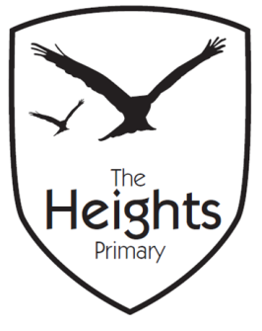
The Heights Primary School
Reception Parent Planner: Autumn 1 Week 3
Dear Parents/Carers
This term our theme is: All About Me This week our theme is: Faces
Our sounds this week are: /i/n/m/d/ tricky words: I
Our number this week are: count to 20 and backwards from 10 learn correct formation of 1,2,3, 4 using Ten Town number rhymes
This week we will be covering the following in our seven areas of learning:
Communication and Language | We are learning to talk with each other. Taking turns to speak and listen. Speaking skills: Share our “all about me” bags. Listening skills: listen to and join in with learning time.
Personal Social and Emotional Development | Know about similarities and differences between themselves and others. Our first circle time. Learn the circle time rhyme and rules.
Physical Development | Multi-skills PE session and adventure playground to develop gross motor strength and coordination. Use our fingers and hands with developing strength and coordination engaging in finger gym and other activities.
Literacy | Listen for initial sounds in words. Orally blend 2 letter words using sounds we know eg. at, it. Investigate rhyming words. Continue and create our own rhyming strings eg. cat, sat, mat, hat.
Mathematics | Count forwards to 20 and backwards from 10. Recognise and order numbers. Learn the correct formation of numbers 1,2,3,4.
Expressive Arts and Design | Make a collage face on a paper plate, selecting textures and colours and cutting materials to size.
Understanding the World | Plan our role-play areas. Explore similarities and differences in our own faces and face images. Access simple programs on the computer independently eg. Purple mash: face/me

Please support your child by practising the sounds in their phonics book, their blending card and helping them to explore and read their school sharing book every day for 5-10 minutes using the guide in their Reading communication diary.
You can also help your child with their learning this week by……. Listen out for words that rhyme in familiar nursery rhymes. Try making a rhyming string eg. Jill, hill, till, bill, fill, will
Parent and child challenge for the term!
Can you help your child to … find a way transport an acorn across a table? Any photos of your attempts would be welcomed! We display them on one of the boards in the corridor.
If you have any questions about how to help your child with their learning please see your child’s teacher. If you would like to become more involved in school life please see the PTA website: and/or speak to your child’s teacher about any skills that you have that could be used in school. We are always looking at ways to include our talented parent’s in school life. You may like to check out the following useful website: foundationyears.org.

The Reception Team

