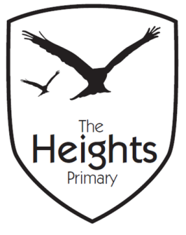
The Heights Primary School
Reception Parent Planner: Autumn 1 Week 4
Dear Parents/Carers
This term our theme is: All About Me This week our theme is: Families
Our sounds this week are: /g/o/c/k/ tricky words: the/The
Our number this week are: formation of 5,6 count and order numbers to 10/20
This week we will be covering the following in our seven areas of learning:
Communication and Language | We are learning to pay attention and focus during individual, group and whole class activities, join in and answer questions. We continue with “Show and Tell” using “All About Me” bags.
Personal Social and Emotional Development | Belonging: we all belong to different groups eg. family, community, school, class, house etc. Families can be all types of sizes and combinations of people, who may live in together or in different places.
Physical Development | Multi-skills PE session. Finger gym activities eg. threading beads and placing pegs on peg boards
Literacy | Begin to put sounds together to read 2 and 3 letter words using the letter sounds introduced so far. Write labels for pictures. Write in role play areas using writing frames, letter formation
Mathematics | Order numbers, solve missing number problems, say what is the next or previous number/ one more or less than a given number. Sort and compare sets saying which set has more/fewer, same as.
Expressive Arts and Design | Junk modelling: learn how to use the tape dispenser safely, select resources needed and talk about intentions. Create a “snippings“ collage. Use paint: select colours and brush thickness for project.
Understanding the World | Continue to develop our outdoor role-play areas. Introduce the block play and construction areas. Use Purple Mash “Paint” to develop mouse co-ordination as children create pictures and patterns.

Please support your child by practising the sounds in their phonics book, their blending card and helping them to explore and read their school sharing book every day for 5-10 minutes using the guide in their Reading communication diary.
You can also help your child with their learning this week by……. Encouraging them to practise writing their name using correct letter formation. Remember to use a capital letter for the first letter only, the rest should be lower case.
Parent and child challenge for the term!
Can you help your child to … find a way transport an acorn across a table? Any photos of your attempts would be welcomed!
If you have any questions about how to help your child with their learning please see your child’s teacher. If you would like to become more involved in school life please see the PTA website: and/or speak to your child’s teacher about any skills that you have that could be used in school. We are always looking at ways to include our talented parent’s in school life. You may like to check out the following useful website: foundationyears.org.

The Reception Team

