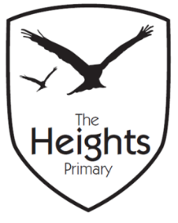

The Heights Primary School
Year 3 Parent Planner: Autumn 1 Week 3

Dear Parents/Carers,

This term our theme is: Fantastic Pharaohs

This week we will be:

English | This week, we will continue to read and enjoy, ‘There’s a Pharaoh in our bath’. We will use drama to explore how the main characters are feeling and we will investigate how the author builds tension. We will then use Chapter 4 of the story to inspire our own writing. We will storyboard the chapter and then learn the skill of ‘boxing up’.
Mathematics | In Maths, we will continue to develop our understanding of place value. We will be exploring the value of each digit in a 3 digit number and will be partitioning large numbers. We will become proficient at adding 10 and 100 to any number, even when crossing boundaries. We will also continue our number investigation during our problem solving session.
Topic | We will continue to build on our understanding of Egypt and in particular the river Nile. We will begin to consider the importance of the Nile to the Ancient Egyptians for farming.

Thank you for your support listening to your child read and helping them to learn their spellings. We will be launching the Cracking Times Table scheme at the end of the week and your children will be bringing home CTT books so that you can monitor and support their progress.
If you have any questions, don’t hesitate to speak with us on the door in the morning, at pick up at the end of the day or by email via the school office.
Best wishes,
Mrs Sanigar, Mrs Wells, Ms Ford and Mrs Harrison

