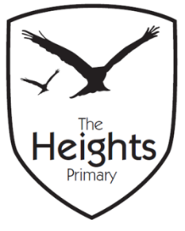

The Heights Primary School
Year 3 Parent Planner: Autumn 1 Week 4

Dear Parents/Carers,

This term our theme is: Fantastic Pharaohs

This week we will be:

English | This week, we will continue to write our own version of ‘There’s a Pharaoh in our Bath’. We will be focusing on starting our sentences in different ways and including powerful description in our writing. At the end of the week, we will be editing and publishing our work using a dictionary to check our spellings.
Mathematics | In maths, we will be adding 3 digit numbers using the expanded written method. We will be partitioning 3 digit numbers and lining them up in Hs, Ts and Os. We will be using our knowledge of addition to investigate number patterns and solve missing number problems.
Topic | We will begin to consider the importance of the Nile to the Ancient Egyptians for farming. In science, we will continue to investigate forces, looking at how well an object can slide on different materials.

Thank you for your support listening to your child read and helping them to learn their spellings. Cracking Times Tables launched last Friday and your children will be bringing home CTT books so that you can monitor and support their progress.
If you have any questions, please don’t hesitate to speak with us on the door in the morning, at pick up at the end of the day or by email via the school office.
Best wishes,
Mrs Sanigar, Mrs Wells, Ms Ford and Mrs Harrison

