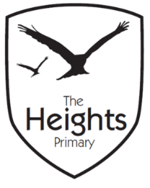

The Heights Primary School
Year One Parent Planner: Autumn 1 Week 4
Dear Parents/Carers
This term our theme is: The Great Fire
This week we will be:
English | This week will be focussing on non-fiction books and looking at the elements of non-fiction writing ie; labels, lists, contents and index pages. We will go on a short autumn walk around Westfield Park and write a list of what we find.
Mathematics | In Maths we will be using Numicon to add and subtract numbers from 1- 20. We will be focussing in particular on the teen numbers and our pattern recognition with Numicon.
Topic | In History we will be creating our own timeline of events and exploring the similarities and differences between Tudor and modern day houses. In Art we will be making silhouettes to create our very own fire pictures. In Science we will be investigating different materials such as glass, metal, wood, plastic and rock. We will also be learning the names of the four countries that make up the United Kingdom and their capital cities.

P.E - Please ensure all children have a full PE kit. Our PE lessons are on Mondays and Thursdays. A full P.E kit contains a spare set of PE socks, PE t-shirt, PE jumper, PE shorts, joggers and trainers. All kit must be named and brought in every Monday so it is available all week.
Reading - Please ensure children bring their reading book and reading records to school each day so that they can change their books. Please record, in their reading records, when you have listened to them read.
Weather – As the weather changes please ensure children have a pair of named wellies and a waterproof coat in school.
Key Stage 1 Meeting – Our meeting is on Tuesday 25th September 2018 from 6-7pm.

Thank you,
The Year 1 Team

