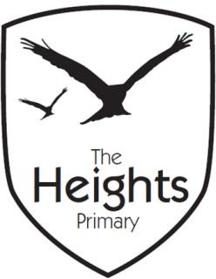

The Heights Primary School
Year 5 Parent Planner: Autumn 2 Week 1
Dear Parents/Carers,
I hope you’ve all had a nice week away from school. We will be beginning our work on The Oratory History Competition entries this week. On Friday, we will be celebrating the Mexican festival of Día de Muertos. This is building on the work in PSHE about Celebrating Differences and also our RE topic of Festivals.

This term our theme is Invasion! (The Vikings)
English | In English, we will be writing Newspaper reports over the next 2 weeks. We are going to start focussing on the skills that make up good writing (planning, drafting, editing and publishing).
Mathematics | This week, we will be finishing off our Addition and Subtraction topic. We will be focussing on multi-step word problems which some children find very challenging.  We will be teaching some children using bar modelling as it can improve their understanding, especially of problems involving finding the inverse. The link below explains what bar modelling is and how it can help your child understand why they do certain processes.  https://mathsnoproblem.com/en/mastery/bar-modelling/
Science | Building on the work we did last term on the properties of materials, children will begin understanding how materials change.  This week, we will be looking at materials which dissolve.  Key Vocabulary: variables, accuracy, precision, enquiry, solid, liquid, gas, dissolve, soluble, solute, solution, saturated.
Topic | History: We will be building on the enquiry work we began doing last term by trying to use evidence to find out who the Vikings were.  RE: This term’s RE topic is Festivals. Children will be discussing what a festival is and why we celebrate them. They will be using their current understanding and knowledge to design title pages for their RE Books which they will add to at the end of the term.  Día de Muertos – On Friday, we will be celebrating the Mexican festival of the day of the dead. We will be exploring the traditions and importance of this day for many people. We will be:  - researching how people celebrate the lives of people they’ve lost.  - exploring the amazing art of the festival, in particular the calveras.  - Tasting pan de muerto and Mexican hot chocolate.  - Watching The Book of Life (2014). The film has a PG rating. The link below has some more information why it was given this rating. If you have any concerns about the film, please don’t hesitate to come and see me.  https://www.imdb.com/title/tt2262227/parentalguide?ref_=tt_ql_stry_5
Information | Parent Consultations – Bookings open today (29/10/18). I look forward to seeing as many of you as possible. If you cannot make the times available, please don’t hesitate to contact the office so we can arrange another time that suits you.

