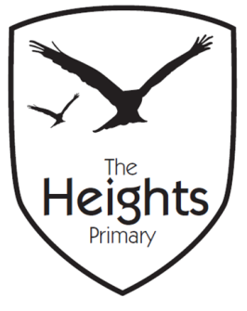
The Heights Primary School
Reception Parent Planner: Week 5
Dear Parents/Carers
This term our theme is: All About Me, All About Us Our Focus this week is: My body
Our sounds this week are: /ck/e/u/r/ Our numbers this week are: formation of 7, 8
This week we will be covering the following in our seven areas of learning:
Communication and Language | Express our needs, views and feelings in appropriate ways. Listen and respond to ideas, needs, views, feelings expressed by others. Work and play cooperatively together, negotiating plans and activities.
Personal Social and Emotional Development | Similarities and differences between ourselves and others. We are all special, we have different views, needs and feelings. We are all good at different things and for some things we sometime need a little practise or help.
Physical Development | Multi-skills PE session. Dough Disco to develop gross and fine motor strength and coordination. Letter/number formation
Literacy | Oral blending (reading) and segmenting (spelling) of CVC words eg. man, sit, dog, mop etc. Write labels for our models. Make labels for parts of the body. Play phonics games to further develop our skills of hearing the sounds in words and matching them to letters.
Mathematics | Continued learning and development of our skills of counting, recognising and ordering numbers as well as forming numerals correctly when recording them
Expressive Arts and Design | Create collage skeletons as well as free choice with art and junk modelling resources. Introduction to the small world and block play for creating imaginative narratives.
Understanding the World | My body – what can it do? How can I move? Observe and talk about our skeleton. ICT: Purple mash paint projects – My Body – draw and label using paint tools.

Please support your child by practising the sounds in their phonics book and helping them to explore and read their school reading book every day for 5-10 minutes using the guide in their Reading communication diary.
You can also help your child with their learning this week by……. Praising independence and perseverance when tacking all manner of activities from putting on your own coat and doing it up and dressing/undressing to mastering writing own name using correct formation or trying new activities outside of school for instance swimming lessons or riding a bike. We would love to hear about any of these so we can celebrate too.
Parent and child challenge for the term!
Can you help your child to … find a way transport an acorn across a table? Any photos of your attempts would be welcomed!
If you have any questions about how to help your child with their learning please see your child’s teacher. If you would like to become more involved in school life please see the PTA website: and/or speak to your child’s teacher about any skills that you have that could be used in school. We are always looking at ways to include our talented parent’s in school life. You may like to check out the following useful website for pronunciations of phonetic sounds: http://www.youtube.com/watch?v=IwJx1NSineE&feature=related as recommended in our recent Parent talk.
Best wishes
The Foundation Stage Team

