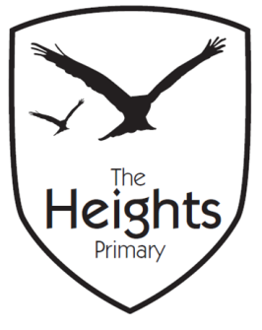
The Heights Primary School
Reception Parent Planner: Week 6
Dear Parents/Carers
This term our theme is: All About Me, All About Us This week our theme is: Autumn
Our sounds this week are: /h/b/f/l/ Tricky words: no, go Our numbers this week are: 9, 10, 0
This week we will be covering the following in our seven areas of learning:
Communication and Language | Become confident to speak to others about own needs, wants, interests and opinions.  Use our language skills to explain our observations and ideas about Autumn
Personal Social and Emotional Development | What does it mean to co-operate and work together? We need to  take turns and share fairly, listen to and take on board the ideas of others. Consider the consequences of our words and actions on others.
Physical Development | Multi-skills PE session. Get changed independently, dough gym gross motor workout. Daily access to fine motor activities to develop pincer grip strength and coordination. Scissor skills
Literacy | Practise “sound talk” (oral segmenting/spelling), Oral blending (reading) to match words to pictures. Guided reading textless book. Write a descriptive caption about Autumn.
Mathematics | Continue development of counting, recognising numbers, ordering numbers and writing numbers using the correct formation
Expressive Arts and Design | Autumn creative activities, printing, drawing, painting, collage, combining different media, make a clay hedgehog
Understanding the World | Explore and talk about signs of Autumn and seasonal changes  ICT: purple mash paint-Autumn,

Please support your child by practising the sounds in their phonics book and helping them to explore and read their school reading book every day for 5-10 minutes using the guide in their Reading communication diary.
You can also help your child with their learning this week by……. Looking for signs of Autumn and talking about what is seen and what is happening
Parent and child challenge for the term!
Can you help your child to … find a way transport an acorn across a table? Any photos of your attempts would be welcomed!
If you have any questions about how to help your child with their learning please see your child’s teacher. If you would like to become more involved in school life please see the PTA website: and/or speak to your child’s teacher about any skills that you have that could be used in school. We are always looking at ways to include our talented parent’s in school life. You may like to check out the following useful website for phonetic pronunciation: http://www.youtube.com/watch?v=IwJx1NSineE&feature=related as recommended in our recent Parent talk. If anyone is able to help us on a Friday with sound books please let Mrs Rizvi know.
Best wishes from The Reception Team

