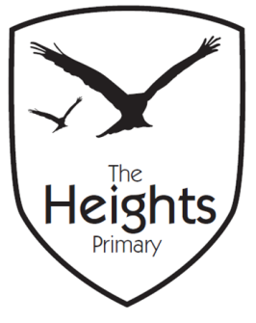

The Heights Primary School
Year 4 Parent Planner: Autumn 1 Week 6
Dear Parents/Carers

This week our theme is Guatemala and North America

English | We will be starting our new English topic on CS Lewis and ‘The Chronicles of Narnia.’ The children will find out about the books in the series by reading blurbs. They will then start reading ‘The Lion, the Witch and the Wardrobe’ and practise reading with expression. The children will use the Narnia setting as inspiration for creating their own imaginary place.
Maths | In Maths the children will be revising and consolidating their learning on place value and number. They will use their understanding of place value to say whether one number is greater or smaller than another. They will look at the place value of decimal numbers, making links to money.
Topic | Last week, we had a change of plan in computing and have postponed internet safety until after half term. For now, the children will be continuing their google slides on North America and Guatemala. They will also be having a topic focus on earthquakes and volcanoes in central America and will use the chrome books to research the ‘ring of fire.’  In R.E. the children will be completing their learning on Abrahamic faiths and will analyse the similarities and differences between these faiths. If there are any parents who would like to talk to the class about their Christian, Islamic or Jewish faith, we would love to hear from you.  The children have been creating abstract art in the style of Julian Cache Mendoza. Once they have had enough practice of this in their art books they will begin to create final pieces for display.  In Science the children have begun to plan investigations into tooth decay. They have been writing scientific questions and considering the variables. They will complete these plans this week ready to carry out the investigation next week.  In PSHE, the children will have a focus on rewards and consequences.

Best wishes,
Mrs Thomas and Miss Reynolds

