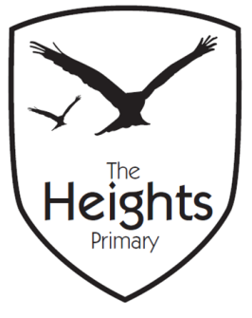

The Heights Primary School
Year 4 Parent Planner: Autumn 1 Week 7
Dear Parents/Carers

This week our theme is Guatemala and North America

English | The children will be completing half termly reading and grammar assessments this week. In addition to this, the children will be taking inspiration from CS Lewis and writing a description of a snowy scene using expanded noun phrases, adverbs, similes and alliteration. They will also be planning and writing a ‘Giant’ story.
Maths | In Maths the children will be revising and consolidating their learning on place value and number. They will then complete a written assessment and mental maths assessment.
Topic | In Science, the children have now completed their planning for their investigations into tooth decay. This week they will set up their investigations, record their results and write conclusions. They will complete an assessment on their ‘Animals and Humans’ topic.  In Art the children will complete their Julian Mendoza inspired abstract pieces of Art.  In computing the children will focus on internet safety.  In PSHE, the children will be using role play cards as a starting point for discussion on rewards and consequences.
Coming up…
Mighty Maya Day
On Wednesday 31st October we shall be launching our Mayan topic with a ‘Mighty Maya Day’. The children will use pictures to find out about aspects of Mayan life. They will also take part in a music workshop in which they will collaboratively compose some rainforest music. In addition, they will write their own version of ‘The Chocolate Tree.’

On this day the children are invited to come to school dressed in a costume of a Mayan theme. Last year some children came dressed in Mayan style robes and others came dressed as a creature that may be found in a Mayan rainforest. We do not expect anyone to have to buy costumes and will encourage children to put together costumes from things they may have at home. For example, last year for Mayan animals some children just wore plain leggings with a plain long sleeved top and then a mask which represented the animal of their choice. We hope the children thoroughly enjoy their day.
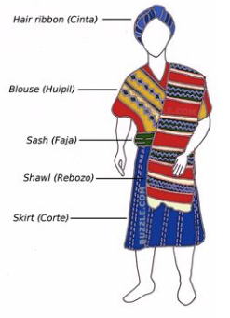
Have a lovely half term.
Best wishes,
Mrs Thomas and Miss Reynolds

