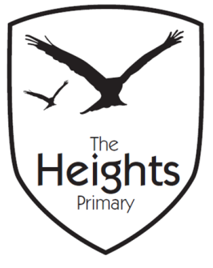

The Heights Primary School
Year 4 Parent Planner: Autumn 2 Week 1
Dear Parents/Carers
We hope you had a restful half-term. We have an exciting beginning to our term with a Mighty Maya Day this Wednesday.
This week our theme is Ancient Maya

English | This week we will be reading The Chocolate Tree; an Ancient Maya myth which explains how the Ancient Maya’s discovered chocolate. The children will be re-telling the story in six key sentences. They will also be finding important information in the text and discussing insight to character.
Maths | In maths, we will be looking at addition. The children will start the week learning to add two and three digit numbers mentally before being introduced to the column method for addition.  As a class, we will finish revising the 6 times tables before we start reciting our 7 times tables.
Topic | In Science, we will start our new topic- Living Things and their Habitats. The children will revise their knowledge of sorting as we investigate the different groups we could sort a range of animals into. We will remind the children of the mnemonic ‘Mrs Gren’ and of how the seven life processes are manifested in plants and animals  In music the children will be composing a piece of music relating to the rainforest.  In computing the children will focus on coding and using Scratch to programme a series of instructions.  In PSHE we will be starting our new topic- Celebrating Difference. We will learn about the importance of accepting and celebrating everyone’s unique talents.
Coming up…
Mighty Maya Day
On Wednesday 31st October we shall be launching our Mayan topic with a ‘Mighty Maya Day’. The children will use pictures to find out about aspects of Mayan life. They will also take part in a music workshop in which they will collaboratively compose some rainforest music. In addition, they will write their own version of ‘The Chocolate Tree.’ We do not expect anyone to have to buy costumes and will encourage children to put together costumes from things they may have at home.

As the weather is becoming more inclement could we ask that children have wellington boots at school so they are able to play outside.

Best wishes,
Mrs Thomas and Miss Reynolds

