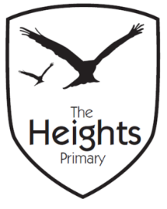

The Heights Primary School
Year 3 Parent Planner: Autumn 1 Week 5

Dear Parents/Carers,

This term our theme is: Fantastic Pharaohs. This week we will be:

English | This week, our spelling test will take place on Tuesday. On Monday, we will be independently writing a narrative opening using a picture stimulus. We will be trying to apply everything we’ve learnt over the last couple of weeks in our writing. We will go on to look at word classes and revise how direct speech is punctuated before applying these rules in our own work.
Mathematics | In maths, we will be adding 2 digit numbers to 3 and 4 digit numbers using a number line. We will go on to solve subtraction questions by counting back on a number line. We will end the week by subtracting multiples of 10 and adjusting.
Topic | This week in our topic work, we will be learning how the Egyptians wrote and communicated. We will be translating Egyptian words into hieroglyphs as well as reading messages written in hieroglyphics. In science, we will be investigating friction using spinning tops.

Thank you for your support listening to your child read and helping them to learn their spellings. Cracking Times Tables launched last Friday and your children will be bringing home CTT books so that you can monitor and support their progress.
If you have any questions, please don’t hesitate to speak with us on the door in the morning, at pick up at the end of the day or by email via the school office.
We look forward to seeing you tonight at the Year 3 meeting.
Best wishes,
Mrs Sanigar, Mrs Wells, Ms Ford and Mrs Harrison

