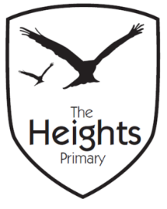

The Heights Primary School
Year 3 Parent Planner: Autumn 1 Week 6

Dear Parents/Carers,

This term our theme is: Fantastic Pharaohs. This week we will be:

English | This week, we will be exploring poetry. We will be reading and listening to a range of different poems and identifying some of the key features. We will go on to watch Michael Rosen perform one of his poems before creating our class success criteria. We will then be learning and performing ‘Melvin the Mummy’ in small groups.
Mathematics | In maths, we will be subtracting by counting up, using a number line to help us. We will go on to solve subtraction questions using the formal written method and by the end of the week will be using exchange.
Topic | This week in our topic work, we will be completing our Egyptian portraits. We will also be learning about what the Egyptians wore and designing a piece of Egyptian jewellery. In science, we will be investigating which materials are magnetic.

We have been doing a lot of number work over the last couple of weeks. It would be fantastic if you could practise counting forwards in 10s and backwards in 1s and 10s from any 3-digit number. Take care when crossing boundaries.
Thank you for your support listening to your child read and helping them to learn their spellings. Spelling books need to come in every day and CTT books need to come in on a Friday. Please violins come in every Wednesday.
If you have any questions, please don’t hesitate to speak with us on the door in the morning, at pick up at the end of the day or by email via the school office.
Best wishes,
Mrs Sanigar, Mrs Wells, Ms Ford and Mrs Harrison

