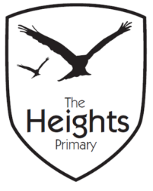

The Heights Primary School
Year 3 Parent Planner: Autumn 1 Week 7

Dear Parents/Carers,

This term our theme is: Fantastic Pharaohs. This week we will be:
English | This week is assessment week and we will be demonstrating everything we have learnt over the past term. At the end of the week we will go on to write our own poems based around autumn.
Mathematics | In maths, we will be demonstrating our addition and subtraction knowledge at the beginning of the week. We will then go on to look at multiples of 4 and 8, find out how we can multiply by doubling and apply our knowledge to one and two step word problems.
Topic | This week in our topic work, we will be creating Egyptian collars based on the designs we produced last week. In science, we will be measuring the strength of magnets through different investigations.

We have been doing a lot of number work over the last couple of weeks. It would be fantastic if you could practise counting forwards in 10s and backwards in 1s and 10s from any 3-digit number. Take care when crossing boundaries.
Thank you for your support listening to your child read and helping them to learn their spellings. Spelling books need to come in every day and CTT books need to come in on a Friday. Please can violins come in every Wednesday.
If you have any questions, please don’t hesitate to speak with us on the door in the morning, at pick up at the end of the day or by email via the school office.
We hope you all have a fantastic half term.
Best wishes,
Mrs Sanigar, Mrs Wells, Ms Ford and Mrs Harrison

