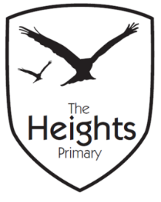

The Heights Primary School
Year 3 Parent Planner: Autumn 2 Week 1

Dear Parents/Carers,
This term our theme is: Fantastic Pharaohs. This week we will be:
English | This week we will be having a go at writing our own firework poems before going on to look at non-chronological reports. We will be reading lots of examples of non-chronological reports and learning how they are structured.
Mathematics | In maths, we will be looking at division. We will be learning how we can use our times tables to help us solve division questions and at the end of the week will be applying our division knowledge to solve word problems. Please can your child practise their current times tables as often as possible.
Topic | This week in our topic work, we will be looking at Egyptian pyramids and learning about how they were constructed. In science, we will be exploring and investigating how and why magnets repel and attract each other.

Welcome back! We hope you all had a lovely half term.
As we are now heading towards the winter, please can you ensure your child has a pair of correctly sized wellies in school at all times.
Thank you for your continued support listening to your child read and helping them to learn their spellings. Spelling books need to come in every day and CTT books need to come in on a Friday. Please can violins come in every Wednesday.
If you have any questions, please don’t hesitate to speak with us on the door in the morning, at pick up at the end of the day or by email via the school office.
We hope you all have a fantastic half term.
Best wishes,
Mrs Sanigar, Mrs Wells, Ms Ford and Mrs Harrison

