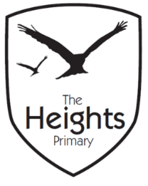

**The Heights Primary School**

**Year One Parent Planner: Autumn 1 Week 5**

Dear Parents/Carers

This term our theme is: **The Great Fire**

This week we will be:

|  |  |
| --- | --- |
| English | In English we will continue to look at Non Fiction writing. We will continue to write lists and labels. We will also begin to listen and explore poetry. We have a Big Writing lesson this week, where we will read some of Samual Pepys’ diary entries to influence our writing. |
| Mathematics | We will continue to learn about Addition and Subtraction. We will use Numicon to add and subtract numbers, focussing on teen numbers and Numicon recognition. |
| Topic | In Art we will create pictures of what Mr Pepys might have seen from his window. In Science we are considering why day lengths change with the seasons. During Music we will be learning to sing “Londons Burning.” In PE we will be learning a dance that is linked to the Great Fire of London. |

**P.E** - Please ensure all children have a full PE kit for our first outdoor PE lesson on Monday. Our PE lessons will be on Mondays and Thursdays. A full P.E kit contains a spare set of **PE socks**, PE t-shirt, PE jumper, PE shorts, joggers and trainers. All kit must be named and brought in every Monday so it is available all week.

**Reading -** Please ensure children bring their reading book and reading records to school each day so that they can change their books. Please record in their reading records when you have heard them read.

**Spellings** – Your child is now bringing spellings home each week in their spellings book. There is no need to write in this book. The children should practise their spellings at home and will be asked to write their spellings in a random order on Mondays. Your child’s spellings will be highlighted green when correct and orange if they made a Marvellous Mistake. Children need to get all six spellings correct to move to the next level of spellings.

Thank you,

The Year 1 Team