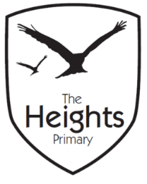

The Heights Primary School
Year One Parent Planner: Autumn 1 Week 6
Dear Parents/Carers
This term our theme is: The Great Fire
This week we will be:
English | In English we will begin to look at sensory poetry and use our word banks to create our own autumn and Great Fire of London poems.
Mathematics | In Maths we will be exploring 2D and 3D shapes. We will be learning to name 2D shapes and making shape pictures. We will also be making monsters and robots using 3D shapes. In Computing we will make shape patterns.
Topic | We are exploring the differences and similarities between firefighters today and in 1666. We are making a collage of the Great Fire of London exploring different materials as part of Art, Topic and Science. We will design a Tudor house in preparation for making wooden houses next term and in RE we are looking at the words used in religion and what they mean.
Reading - Please ensure children bring their reading book and reading records to school each day so that they can change their books. Please record in their reading records when you have heard them read.
Spellings – Your child is now bringing spellings home each week in their spellings book. There is no need to write in this book. The children should practise their spellings at home and will be asked to write their spellings in a random order on Mondays. Your child’s spellings will be highlighted green when correct and orange if they made a Marvellous Mistake. Children need to get all six spellings correct to move to the next level of spellings.
Maths 3D shape – On Friday we are building robots using 3D shapes. Please could you bring in any cardboard packaging (cuboids, cubes and triangular prisms etc.)
Art - We are creating a Great Fire collage in class next week and would be grateful for any donations. We are looking for red, orange, black and brown collage materials such as off cuts of fabric, any clean packaging, sweet wrappers, foil, cellophane etc.
Thank you,
The Year 1 Team

