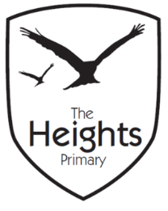

**The Heights Primary School**

**Year One Parent Planner: Autumn 1 Week 7**

Dear Parents/Carers

This term our theme is: **The Great Fire**

This week we will be:

|  |  |
| --- | --- |
| English | In English we will be completing some assessments We will also be looking back through the work in our books and learning how to fix marvellous mistakes with our purple fix it pens. |
| Mathematics | In Maths we will also be doing assessments. We will also be learning how to make 3D shapes from nets. |
| Topic | We will be creating 3D Tudor houses to complete our collage of ‘The Great Fire of London’. |

**Reading -** Please ensure children bring their reading book and reading records to school each day so that they can change their books. Please record in their reading records when you have heard them read.

**Spellings** –The children should practise their spellings at home. They will be asked to write their spellings in a random order on Mondays. Your child’s spellings will be highlighted green when correct and orange if they have made a Marvellous Mistake. Children need to get all six spellings correct to move to the next level of spellings.

**Topic –** The Museum of London are running interactive Great Fire of London walks during October and November where children can explore how the fire started and was eventually stopped. They will also visit sites linked to The Great Fire of London. If you are interested in doing this as a half term activity, please see the following website.

https://www.museumoflondon.org.uk/museum-london/event-detail?id=73409

Thank you,

The Year 1 Team