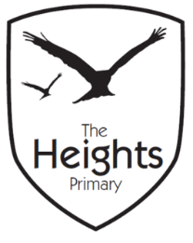

The Heights Primary School
Year One Parent Planner: Autumn 2 Week 1
Dear Parents/Carers
This term our theme is: The Great Fire
This week we will be:
English | In English we will be looking at stories with predictable endings. We will retell and perform The Three Billy Goats Gruff and learn more about sequencing and story mapping. We will also be learning to edit and improve our work.
Mathematics | In Maths we will be handling money and finding out about British coins. We are opening The Heights Corner Shop in the Year 1 Intervention classroom this week to bring our learning to life. We will also be learning to tell the time for O’clock!
Topic | We will begin to create our wooden Tudor houses for ‘The Great Fire of London’. The children will be shown how to use a saw safely to cut their wood to the correct size and will be supervised at all times. We will also continue to learn our Great Fire of London song which we hope to perform in an upcoming assembly.

Topic – The Museum of London are running interactive great Fire of London walks during October and November where children can explore how the fire started and was eventually stopped. On the walk they have the opportunity to visit sites linked to The Great Fire of London.
https://www.museumoflondon.org.uk/museum-london/event-detail?id=73409
R.E – We are visiting Caversham Methodist Church on Thursday to experience and discuss Christianity and explore and identify religious artefacts found inside a Church.
Thank you,
The Year 1 Team

