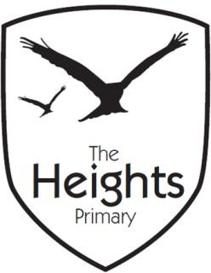

The Heights Primary School
Year 5 Parent Planner: Autumn 2 Week 5

This term our theme is Invasion! (The Vikings)
English | In English, we are moving on from our work on Balanced Arguments. The children worked very hard to compare and contrast ideas, and we will be revisiting this later in the year.  We will be beginning our build-up towards this short term’s big write. We will be working on the Arthurian legend of Sir Gawain and the Green Knight. By comparing this to other legends, we will be doing lots of group writing and editing to ensure all children are thinking about what they might want write about next week.
Mathematics | This week, we will be continuing our work on formal methods for division.  Some children will also be continuing their practise of long multiplication in the afternoons. We want to make sure all children are comfortable and understand what they need to do.
Science | This week, we will be finishing off our work on the changes of materials. We will be considering what an irreversible reaction is and children will be able to explain which reactions cannot be reversed.
Topic | RE: Children will be learning about the Jewish festival of Hanukah.  PE: As we didn’t have much time in the KS2 hall last week, this week we will be continuing to create Viking long ships with our bodies.  PSHE: We will be considering what differences we have between the UK and countries in the developing world.
Information | Just a little reminder to ensure that your children have wellies (or old trainers) to change into for lunchtimes and break times. We go to the park every day for lunch and twice a week for break. If children wear PE trainers, this then they become unwearable inside.  I have been encouraging some children not to join up their writing when doing spelling tests. They understand that if I think their letters don’t look like the letter they meant to write, the whole spelling is marked as wrong.  Spelling Words this week: Year 5/6 Words  Accommodate  Accompany  According  Achieve  Aggressive  Amateur  Ancient  Apparent  Appreciate  Attached  Available  Average  Awkward

