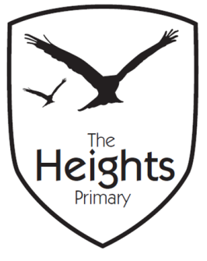

The Heights Primary School
Year 4 Parent Planner: Autumn 2 Week 2

Dear Parents/Carers
This week our theme is Ancient Maya

English | We were so inspired by our reading of The Chocolate Tree last week that, this week, we will be writing our own version of the Ancient Mayan myth. We will be focusing on editing our work and improving it.  Towards the end of the week we will create our own mythological creature based upon the characters in The Chocolate Tree.
Maths | In maths we are continuing to recite the seven times table. This week we will look at the column method for subtraction. Towards the end of the week we will be solving problems in which we will apply our knowledge of subtraction.
Topic | We are enjoying our new topic- Living things and their habitats. This week we will look at classifying animals into vertebrates and invertebrates.  In Topic, we will look at a timeline of the Ancient Mayan people and consider what else was happening in the world at the same time as the Ancient Mayans. We will learn about some of the Ancient Mayan gods and will present our findings to the class.  In PSHE, we will be considering what influences us to make assumptions.  In PE, we will continue to choreograph our dances to the song ‘The Bare Necessities’. We look forward to showing you these soon.  In RE, we will look at the Hindu creation story and consider the similarities and differences.

Coming up…

4CT PE- Teacher led PE in 4CT will be moving from a Monday afternoon to Thursday afternoon.

We look forward to seeing you all at the parents evening this week.

As the weather is becoming more inclement could we ask that children have wellington boots at school so they are able to play outside.

Best wishes,
Mrs Thomas and Miss Reynolds

