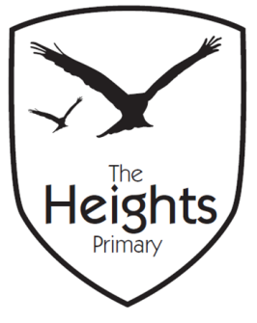

The Heights Primary School
Year 4 Parent Planner: Autumn 2 Week 3

Dear Parents/Carers
This week our theme is Ancient Maya

English | In English this week we will be editing our Big Write piece from Friday. This will involve reading through our work and thinking of two stars and a wish.  Towards the end of the week we will look at the Ancient Mayan creation story which links to our RE topic. In class we will think of our own actions to help remember the story before re-writing it.
Maths | In maths we are continuing to recite the seven times table. This week’s focus in maths will be on word problems using addition and subtraction. We will also look at missing number problems and correctly identifying a number half way between a set of numbers.
Topic | We are enjoying our new topic- Living things and their habitats. This week we will continue to look at classifying animals into vertebrates and invertebrates.  In Topic, we will re-cap the timeline of the Ancient Mayan people and consider what else was happening in the world at the same time as the Ancient Mayans. We will also learn about the Ancient Mayan gods- creating a fact file about them.  In PSHE, we will look at what to do when we think someone is being bullied. This links to our Anti-Bullying week which we will be focusing on this week.  In PE, we will continue to choreograph our dances to the song ‘The Bare Necessities’. We are becoming very proficient at learning our new dances.  In RE, we will be comparing and highlighting the similarities between the Christian and Hindu Creation stories.

Coming up…
Some children still do not have wellies in school which means they are unable to play on the park. Please ensure that all children have wellies. Thank-you.
Best wishes,
Mrs Thomas and Miss Reynolds

