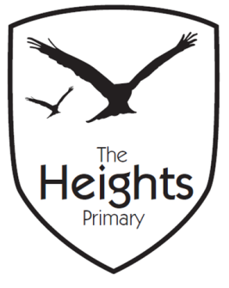

The Heights Primary School
Year 4 Parent Planner: Autumn 2 Week 4

Dear Parents/Carers
This week our theme is Ancient Maya
Road Safety Week

English | In English this week we will be publishing our Ancient Mayan Creation stories. Last week we worked hard to plan and edit our stories.
Maths | In maths we are looking at multiplication. We will explore the divisibility of numbers based upon our multiplication knowledge. We will also look at multiplying a multiple of ten by a single number.
Topic | In Topic, we will be completing our Mayan Gods. The children have enjoyed looking at the different characteristics of Ancient Mayan Gods and creating their own Mayan God.  In Science we will continue our work on vertebrates and invertebrates as we explore the school grounds looking for different examples of vertebrates and invertebrates.  In PSHE, we will continue with our theme of bullying. This week we will consider problem solving and how this can be applied if we see an example of bullying.  In PE, we will continue to choreograph our dances to the song ‘The Bare Necessities’. We are becoming very proficient at learning our new dances.  In RE, we will be learning about the Islamic creation story and exploring the similarities and differences between the creation stories we have looked at so far.

Don’t forget…
It is Inset day this Friday. The children will not be in school on this day. We thank you for your support with this.
Some children still do not have wellies in school which means they are unable to play on the park. Please ensure that all children have wellies.
Coming up…
We have started rehearsing for our carol concert which will be held on Tuesday 11th December.

Best wishes,
Mrs Thomas and Miss Reynolds

