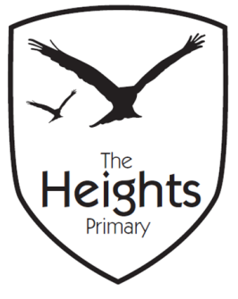

The Heights Primary School
Year 4 Parent Planner: Autumn 2 Week 5

Dear Parents/Carers

This week our theme is Ancient Maya

English | In English this week we will be focusing on reading and grammar. Both classes will finish the story ‘The Lion, The Witch and The Wardrobe’. We will be revising our knowledge of grammatical techniques and applying these to our story writing.
Maths | In maths we are looking at multiplication. We will explore the divisibility of numbers based upon our multiplication knowledge. We will also look at multiplying a multiple of ten by a single number.
Topic | This week in DT we will be tasting tortilla fillings which is linked to our Ancient Mayan topic.  In Science we will continue our work on animals and habitats. 4RR will be taking a walk by the river this week to look at the changing habitats. Please could all children have welly boots in school. 4CT will be doing this the following week.  In PSHE, we will be looking at friendship, considering what makes a good friend. The children will write about their special qualities and features.

Coming up…

In order to help fund our school trip to Fishbourne Palace in March, we will be having a cake sale after school on Thursday. All proceeds of this sale will go towards the cost of our trip.

We will be starting our Benchmarking for this half-term.
We are looking for volunteers to read with the children in the afternoons towards the end of the week. If you are free and would like to volunteer to read with a few children, please contact either Miss Reynolds or Mrs Thomas.

Thank-you for your support.

Best wishes,

Mrs Thomas and Miss Reynolds

