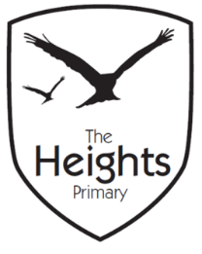

The Heights Primary School
Year One Parent Planner: Autumn 2 Week 2
Dear Parents/Carers
This term our theme is: The Great Fire
This week we will be:
English | In English we are continuing to look at The Three Billy Goat’s Gruff. We will focus on the speech of the different characters and write speech bubbles for the different characters. In Art we will make the characters from plasticine to retell the story. We will also be doing some independent Big Writing at the end of the week.
Mathematics | In Maths we will be looking at measuring length, height and weight. We will be learning to use non-standard units and rulers to measure the length of different objects. Later in the week we will then use scales to weigh objects. We will be focussing on learning key vocabulary such as longest, longer, shortest, shorter, tallest, taller, smallest, smaller, heaviest, heavier, lightest, lightest, more than and less than etc.
Topic | We will continue to build our wooden Tudor houses for ‘The Great Fire of London’ and continue to learn our Great Fire of London song which we will be performing in our next celebration assembly. During indoor P.E we are learning to perform The Great Fire of London through dance.

P.E: Please ensure your child has socks and trainers in their P.E kit. Children will not be able to participate in P.E unless they have a full kit to change into.
Parents Evening: Just a reminder that Parents Evening next week is on Tuesday 6th November 3.50-6.00 and Thursday 8th November 6.00 – 8.30.

Thank you,
The Year 1 Team

