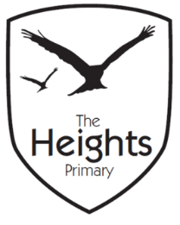

The Heights Primary School
Year One Parent Planner: Autumn 2 Week 3

Dear Parents/Carers
This term our theme is: The Great Fire
This week we will be:
English | In English we are learning how to use adjectives and nouns to make our writing more interesting. Following on from our recount of the Three Billy Goats Gruff we are learning John Fosters poem ‘The School Kids Rap.’ We will be learning actions for this poem as we have been learning to sign in music.
Mathematics | In Maths we will be learning to identify fractions through shape and having a fractions picnic. We will also be comparing fractions and learning about fractions of a quantity.
Topic | We will continue to build our wooden Tudor houses for ‘The Great Fire of London’ and continue to learn our Great Fire of London song which we will be performing in assembly this Friday We are hoping to meet the Caversham Road fire crew either this week or next depending on their availability. We will have a fire safety talk and look at the fire engine.

P.E: Please ensure your child has socks and trainers in their P.E kit. Children will not be able to participate in P.E unless they have a a full kit to change into.
Assembly: The Year 1 children will be performing a Great Fire of London song.

Thank you,
The Year 1 Team

