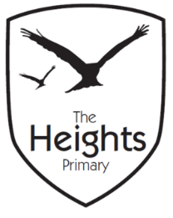

The Heights Primary School
Year One Parent Planner: Autumn 2 Week 4

Dear Parents/Carers
This term our theme is: The Great Fire

This week we will be:
English | In English we will be learning about the Christmas poem ‘Twas The Night Before Christmas’ by Clement Clarke Moore. We will be sequencing and learning to recite this off by heart. We will also be creating our own Christmas poems.
Mathematics | In Maths we are learning about position and direction. We will use what we have learnt about fractions and time to make quarter, half, three quarter and whole turns.
Topic | We will continue to build our wooden Tudor houses for ‘The Great Fire of London.’ We are still hoping to meet the Caversham Road firemen next week, depending on their availability. If we are lucky we will have a fire safety talk and have a look at a modern day fire engine. During PE we are learning to stretch the muscles in our bodies using Yoga and Pilates to strengthen our core, be flexible and think about how our bodies move.

P.E: Please ensure your child has socks and trainers in their P.E kit. Children will not be able to participate in P.E unless they have a full kit to change into.
Inset day: On Friday 23rd November we have an Inset Day so there is no school for the children.

Many thanks,
The Year 1 Team

