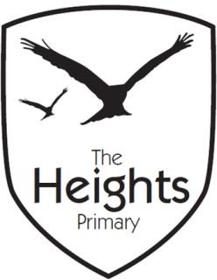

The Heights Primary School
Year 5 Parent Planner: Autumn 2 Week 6

This term our theme is Invasion! (The Vikings)

English | In English, we will be writing our own Arthurian Legends. We will be planning, drafting, editing and publishing. We look forward to reading all of the interesting stories.
Mathematics | This week, we will be multiplying and diving by 10, 100 and 1000. We need to ensure that we can be able to solve these problems mentally. We will be finishing this topic next week.
Science | This week, we will be revising concepts from the whole term so far. We will assess this next week.
Topic | RE: Children will be continuing to learn about the Jewish festival of Hanukah.  PE: We will be using music to create rhythmic movements focussing on beat and tempo.  DT: Children will be designing shields and sails for their Viking Longships.  Computing: We will continue our work on HTML Coding.
Information | We will be announcing the prize winners for the Historical Building project this week.  Please could you check that your child is recording when they’ve read at home. This doesn’t have to be a detailed description, and it doesn’t need to be their level books.

