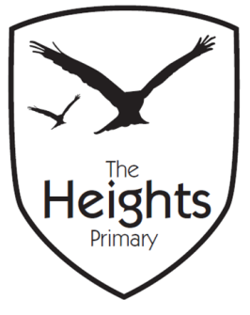

The Heights Primary School
Year 4 Parent Planner: Autumn 2 Week 6

Dear Parents/Carers
This week our theme is Ancient Maya
The Snowman

English | In English this week we are learning the story of The Snowman. We will watch the story and re-tell the story in six simple sentences before we start writing our own snowman story. We hope to be able to share our snowmen stories with key stage one next week.
Maths | In maths we are looking at division. The children have been working hard on using the bus shelter method for division. Towards the end of the week we will complete our maths assessments in multiplication and division.
Topic | This week in DT we will be designing a tortilla recipe which we will make next week.  In Science we will continue our work on animals and habitats.  In PE 4RR will have a basketball lesson after their tag rugby session. Please could all children ensure they have appropriate clothing as they will be spending the afternoon outdoors.  This week we will continue to rehearse our Christmas Carol concert. We look forward to our concert next Tuesday at St. Andrew’s church.

Coming up…
Thank-you for your support of our cake sale last week. We will be using the proceeds towards our school trip to Fishbourne Roman Palace.

We are still looking for volunteers to read with the children in the afternoons towards the end of the week. If you are free and would like to volunteer to read with a few children, please contact either Miss Reynolds or Mrs Thomas. Thank-you for your support.

Best wishes,
Mrs Thomas and Miss Reynolds

