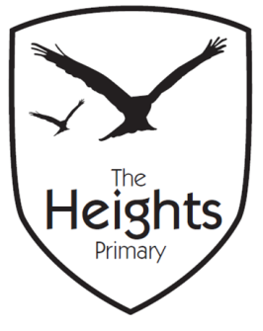

The Heights Primary School
Year 4 Parent Planner: Autumn 2 Week 7

Dear Parents/Carers
This week our theme is The Snowman

What a busy couple of weeks we have! Please keep an eye out for parent mails for all our up-coming events.

English | In English this week we will continue to write our first draft of The Snowman. We hope to publish these in neat and look forward to reading them to the children in early years next week.
Maths | In maths we are revising our knowledge of multiplication and division. We have been working very hard to learn the bus shelter method of division as well as practising the formal method of multiplication. This will prepare us for our maths assessment next week.
Topic | In Science we will continue our work on animals and habitats. 4RR will go on a river walk on Friday the 14th December. Please could all children have wellington boots in school for this as the ground may be muddy.
Coming up…
Thank-you once again for your support of our cake sale which was to raise money towards our school trip to Fishbourne Palace. We are delighted to say that we have raised £183.20. We would also like to take this opportunity to say another big thank-you to those who ran the stall.

This Friday will be the last Cracking Time Tables before the end of term. This week will also be the last spellings although we do encourage the children to practice reading and spelling the year 3 and 4 word lists over the holidays.

Please see our separate end of term letter for all the activities and their dates over the next two weeks.

Best wishes,
Mrs Thomas and Miss Reynolds

