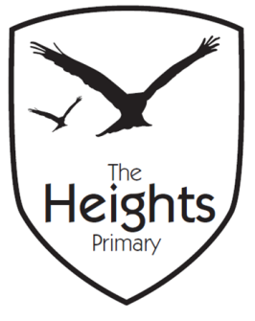

The Heights Primary School
Year 4 Parent Planner: Autumn 2 Week 8

Dear Parents/Carers
This week our theme is Christmas

What a busy week we have!

This week we have been revising and consolidating our knowledge of multiplication and division before our assessments. We will also be making our tortillas this week, 4RR on Wednesday and 4CT on Thursday. Can the children please remember to bring their ingredients on the day they are making the tortillas?

Wednesday is our Christmas lunch day where we will celebrate a Christmas dinner as a class. Throughout the rest of the week we will be making Christmas decorations. On Thursday we are looking forward to reading our Snowman stories to the early years children.

We will be finishing school at 1.30 pm on Friday. Please could the children bring in a carrier bag for Friday to take all of their Christmas things home.

We hope you have a lovely Christmas and look forward to seeing you again in the New Year.

Best wishes,
Mrs Thomas and Miss Reynolds

