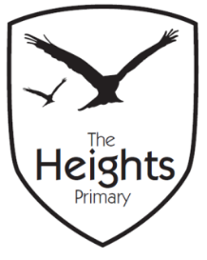

The Heights Primary School
Year 3 Parent Planner: Autumn 2 Week 8

Dear Parents/Carers,

This term our theme is: Fantastic Pharaohs. This week we will be:

English | In English this week we will be writing a narrative inspired by our trip to the pantomime last week. We will create our own success criteria and plan our writing before completing our stories independently. We will carefully edit and check our work to ensure we’ve included everything we needed to make our work successful.
Mathematics | In maths we will be using everything we have learnt this term to help us complete some Christmas based problems and activities.
Topic | This week in our topic work, we will tasting different breads and evaluating them before going on to make our own Egyptian inspired flatbreads. We are also looking forward to some Christmas activities and crafts in class before we finish for the holidays.

Please ensure your child has a pair of correctly sized wellies in school at all times. PE kits also need to remain in school all week. Please could you ensure that every item of clothing that comes into school is clearly named.
Please note that there will be no violin next week or Cracking Times Tables. There will be no spellings set on Monday 17th December however your child can practise spellings from the statutory Year 3/4 spelling list below if they wish to.
We would like to take this opportunity to wish you all a very happy Christmas and a safe, restful holiday.
Best wishes,
Mrs Sanigar, Mrs Wells, Ms Ford and Mrs Harrison

