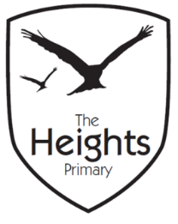

The Heights Primary School
Year One Parent Planner: Autumn 2 Week 6

Dear Parents/Carers
This term our theme is: The Great Fire
This week is Assessment Week:

English | In English we will be doing some assessments in Phonics, Writing and Reading. We will also be looking back through our Independent Writing and English books to fix any Marvellous Mistakes we can find. We will also encourage the children to look at their new targets and consider how they can make improvements to their work next term. Children will have their Reading assessed and will all be Benchmarked before the end of term.
Mathematics | In Maths we will be completing assessments. We will also continue to look at tessellation and repeating patterns.
Topic | We will be continuing to make our Tudor houses in Design & Technology. The children will saw their wood ready so that’s ready for building and decorating. We will also be learning to sew our own Christmas stockings this week. In Science, the children will complete assessments. During our PE lessons we will continue to develop our core and flexibility by learning yoga poses and Pilates. In Art, we will be creating our own Christmas decorations to decorate our classrooms.

P.E: Please ensure your child has socks and trainers in their P.E kit. Children will not be able to participate in P.E unless they have a full kit to change into. PE kit should be sent in on a Monday for the whole week.
Important Dates
Nasal Vaccinations: Children with permission will be having their flu vaccinations on Monday 3rd December.
Christmas Pantomime: Thursday 13th December.
Christmas Jumper Day: We will be wearing our festive jumpers on Friday 14th December.
Christmas Performance Dates: Tuesday 18th and Wednesday 19th December.
Thank you,
The Year 1 Team

