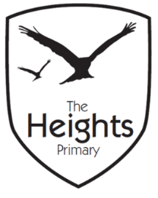

The Heights Primary School
Year One Parent Planner: Autumn 2 Week 7

Dear Parents/Carers
This term our theme is: The Great Fire
This week we will be:

English | In English we are focusing on the Christmas story and writing a recount. We will continue to practise our handwriting and the children will have the opportunity to do some free writing using what they have learnt about nouns, adjectives and verbs.
Mathematics | In Maths we are learning about addition and subtraction using a Christmas theme. We will also revisit our work on number bonds and subtraction facts.
Topic | In Design & Technology we will be continuing to create our Tudor houses so that they are ready for the Great Fire of London in our final week. We will also be continuing to sew our Christmas stockings.  The firefighters are due to visit on Tuesday. We will look at the differences and similarities between firefighters now and in 1666. We will also be learning how to make an emergency call to the emergency services. The children will also be doing lots of rehearsing for our Christmas production.

P.E: Please ensure your child has socks and trainers in their P.E kit. Children will not be able to participate in P.E unless they have a full kit to change into. PE kit should be sent in for the whole week so children can be changed if necessary.
Christmas Performance: We are continuing to practise our production ready for Christmas. If your child is a narrator, please can you ensure they learn their lines over the weekend.
Christmas Panto: We will be attending the Hexagon on Thursday.
Christmas Jumper Day: We will be wearing our festive jumpers on Friday.

Thank you,
The Year 1 Team

