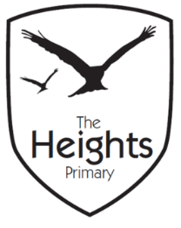

The Heights Primary School
Year One Parent Planner: Autumn 2 Week 8
Dear Parents/Carers
This term our theme is: The Great Fire
This week we will be:
English | In English we will be practicing writing simple sentences and improving our pre-cursive handwriting. We will also be doing some free writing where the children will be encouraged to focus on their finger spaces, capital letters and full stops.
Mathematics | We will be doing Christmas Maths which will focus on a range of skills that we have covered across the term.
Topic | In Design and Technology, we will be making fireman helmets and role playing a fire emergency situation. We will also be practising how to make an emergency phone call. Please practise recalling your home address with your child in preparation for making an emergency call. During our role play, we will be practising the ‘stop, drop and roll’ in case of an emergency. We have now come to the end of our topic ‘The Great Fire’ and the children will have the choice whether they are going to use their houses in our recreation of The Great Fire of London. As ‘London’ burns, we will be singing The Great Fire of London song and London’s burning.

Christmas performance: Tuesday 18th December and Wednesday 19th December 6:30-7.30pm at St Andrews Church.
Children need to arrive dressed in their costume at the Church at 6.15pm.

Please send your child in with a named carrier bag so we can send them home on Friday with their work.

We are still collecting donations of mens shirts for our Art lessons. If you have any old tired ones, please send them in with your child.
Thank you,
The Year 1 Team

