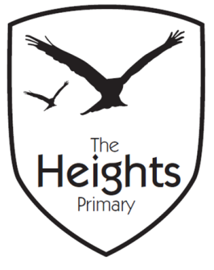

The Heights Primary School
Year 4 Parent Planner: Spring 1 Week 1

Dear Parents/Carers
HAPPY NEW YEAR
This week our theme is Romans

English | The children will be beginning to read ‘Kensuke’s Kingdom,’ by Michael Morpurgo. The children will be working on their comprehension skills by extracting information from the text. They will be discussing Michael Morpurgo’s style and they will write about their family in the style of Michael Morpurgo. Towards the end of the week, the children will be writing a letter from the main character Michael, to his friend Eddy, telling him how things have changed.
Maths | Linking to our Romans topic, the children will be learning about Roman Numerals. They will create Roman Numeral posters and carry out a Roman Numeral investigation. In the latter part of the week, the children will begin their Fractions topic, they will explore fractions and identify equivalent fractions.
Topic | We will be launching our Romans topic with a Romans Day on Wednesday. The children will be invited to come to school dressed as a Roman and will be taking part in many workshop style activities including:  - A Latin lesson in which children will use wax tablets.  - A gladiator game  - A Numismatics (study of coins) competition in which children will need to decipher which coins are real and which are fake and then use their magnifying glasses to identify features on the real ones.  - Use of curse tablets  - A selection of Roman games.  - Roman pottery.  The children’s Art this short term will be linked to Roman mosaics. The children will start this week by looking at examples of Roman mosaics and thinking about ideas for their own mosaics.  In R.E. the children will be exploring leaders and what makes a good leader in preparation for following lessons when they will focus on religious leaders.  In Science, the children will begin to explore electricity by sorting appliances into those that are non-electric appliances and those that use stored (battery) or mains electricity.  The children have now completed their Spanish unit and will return to a focus on French, however they will spend the first few sessions this term looking at the similarities between French and Spanish.  In computing, the children will be describing early forms of animation before computers and consider how computers have made a difference.  In PSHE, the children will begin their Dreams and Goals topic.  Children will be identifying and discussing mood in music.

Best wishes,
Mrs Thomas and Miss Reynolds

