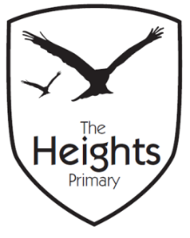

The Heights Primary School
Year 3 Parent Planner: Spring 1 Week 1

Dear Parents/Carers,

This term our theme is: Stone Age Rocks! This week we will be:

English | We are excited to start reading the book Stone Age Boy! We will focus on developing empathy for the main characters, Om and Boy, as well as looking at how the author creates a setting. We will then write our own description of Om’s camp, focusing on the senses.
Mathematics | In maths we will be looking at place value, ordering numbers up to 1000 by placing them accurately on a number line. We will partition numbers and learn how to compare numbers using < > and = symbols.
Topic | We are really looking forward to starting our Stone Age topic this term! We will be trying to get our heads around just how long ago the Stone Age was and then putting key dates into chronological order. In art, we will be looking at how the people at the time used charcoal to create hand images. In science, we will be finding out how our muscles help us to move and naming key muscles in the body.

Welcome back everyone! We hope you’ve all had a fantastic Christmas and that everyone is ready for another busy and exciting term. You should shortly receive our newsletter and curriculum overview for the term ahead which details what we will be learning about.
From Friday 11th January, we will be swimming every week at Queen Anne’s. Swimming kits be needed every Friday; please ensure every item in your child’s bag is clearly named.
Violin lessons start again on Wednesday 9th January and violins need to be brought into school every week.
If you have any questions, please don’t hesitate to pop in and see us.
Best wishes,
Ms Ford, Mrs Harrison, Mrs Sanigar and Mrs Wells

