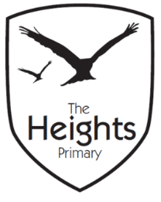

The Heights Primary School
Year One Parent Planner: Spring 1 Week 1
Dear Parents/Carers
This term our theme is: Spectacular Space
This week we will be:

English | In English the children will be learning about suffixes and how to add suffixes to root words. We will also be learning about conjunctions and will be using the word ‘and’ to write compound sentences. As we begin our Space topic the children will explore several different Fiction and Non-fiction books about Space. We will also complete a Big Write lesson following a Space theme this week.
Mathematics | In Maths we will be learning more about place value to ensure the children have embedded this as part of their number work. Later in the week they will apply this knowledge to some problem solving and explore odd and even numbers.
Topic | We are all very excited about starting our Space topic! We will start by contacting an astronaut, listen to an astronaut read Space fiction, from space and we read a space story written by an astronaut! Our Art, this week, views stars in the night sky and in Geography we explore Earths continents from space! In Science this week we will go on a winter walk. We will listen, observe and feel the changes between the seasons. In P.E we are starting gymnastics. We will be learning about parables in R.E.

P.E: Please ensure your child has socks and trainers in their P.E kit. Children will not be able to participate in P.E unless they have a full kit. PE kit should be sent in for the whole week on a Monday.
Wellies: Please can you ensure wellies are sent back in for the start of term ready for our Winter walk.

We would like to thank all of you for your generous cards and gifts. We’ve had a fantastic time with our families.

Thank you,
The Year 1 Team

