The Heights Primary School  82 Gosbrook Road  Caversham  Reading  RG4 8BH  Tel: 0118 357 0123  Email: info@theheightsprimary.co.uk  Headteacher: Mrs Karen Edwards | THE HEIGHTS HIGHLIGHTS  Achieving Success Promoting Individual Responsibility and Excellence  21st December 2018 – Issue 172
Dear Parents and Carers,

I know that I said last week was busy but I think we may have trumped it this week with our Nativity performances and Christmas lunch!

Reception
We have 3 amazing performances of the Nursery Rhyme Nativity to the children in school, grandparents and parents this Tuesday, Wednesday and Thursday. The children were so confident and animated in their performances, it was lovely to watch. Thank you so much to all the Foundation Stage staff for their hard work, which ensured the children were happy to perform in the way that they did. The children were amazing! As well as performing in our Nativity play we have taken part in so many other different Christmas themed activities this week. We’ve made Christmas cards, crafts and decorations and played Christmas themed Maths and computer games.

Years 1 and 2 performed ‘Hosanna Rock’ twice at St Andrew’s Church this week. It was really special to be able to hold our Christmas productions at our local parish Church and Reverend Nigel Jones continues to be incredibly supportive. Thank you so much for your generous donations to the Readifood Charity which totalled £1,222. This will help so many families over the Christmas period.
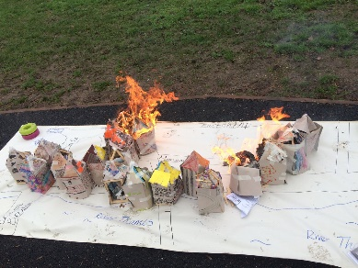
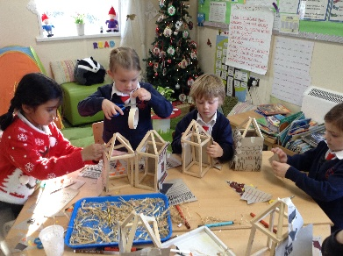
Year 1
Following on from our visit by the Caversham Road Fire Crew last week, we’ve made firefighter’s helmets and role played fire emergency situations. We loved re-enacting the Great Fire of London with the ‘houses’ that we made and were amazed at how quickly the fire spread.

Year 2
We loved practising and performing our Christmas production at St Andrew’s. We’ve finished decorating our material squares in DT and enjoyed making and writing cards to family members.

Year 3
I was blown away by the poems our Year 3 pupils write this week (see Finn’s). As well as working hard on their writing tasks the children were determined to solve the mystery of the ‘Stolen Christmas Pudding’ by using their mathematical skills. The children tasted different breads and then compared them to the Egyptian inspired flatbread they then made.

Year 4
As well as completing different assessments this week, we’ve made and eaten Tortillas – they were delicious! We really enjoyed our river walks and loved spotting and identifying different animals and wildlife in their natural habitats.
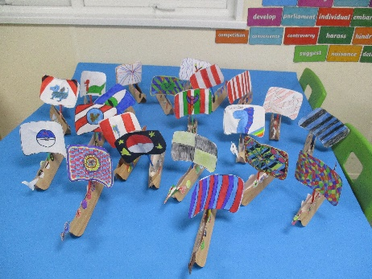

Year 5
A number of Year 5s took part in another football tournament at the JMA this week along with Holly from Year 4 and are really enjoying all these events. They have been making terrifying Viking Longships using skills that they’ve been honing all term and have added their own creativity to produce fantastic shields and sails. They have also published the Arthurian Legends that they’ve edited and written holiday card rhymes.

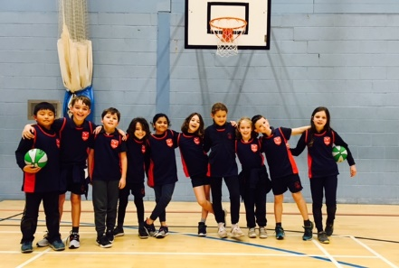
Basketball
Congratulations to all the Year 4 pupils who played in the Reading School’s Basketball tournament on Thursday. The children were a credit to the school. Many thanks to Tom Crisford and Shiplake College for driving them in Shiplake’s minibus and to Chris Ellison for managing the teams.

Farewell
We say a fond farewell this week to Shams and Oishani who are both moving on to new schools out of the area. We wish them both and their families the very best in settling well into their new homes and schools.

Spotlight
Swimming
Eli and Riya (Reception) for earning Level 1 Duckings.
Zachary (Year 4) for earning Level 2 swimming.
Rebecca and Kit (Year 3) for earning Level 3 swimming.
Tara (Year 4) for earning Level 5 swimming.
Darcey (Year 4) for learning to swim 50 metres.
Blue Peter
Audrey (Year 3) for earning a Blue Peter Badge for trying a new sport (football).
Gymnastics
Jack for earning Level 2 Gymnastics and for winning the High Jump competition.
Piper (Year 3) for earning Levels 1-4 for Gymfinity Kids.
Cross Country
Eva (Year 1) for coming 3rd and Oscar (Year 1) for coming 4th.
Cubs
Zachary (Year 4) for being invested in Cubs at 3rd Reading Tigers.
Brownies
Lucy (Year 3) for earning her Pot of Gold Badge and making her Brownie Promise.
Karate
Kacper for earning his 6th Kyu Certificate and also completing the Santa 5K run.
Martial Arts
Kit for earning his Green Belt.
Well done everyone!

DATES FOR YOUR DIARY
Start of Term 3 | Monday 7th January 2019
Year 3 Visit to the Earth Trust | Thursday 14th March 2019

I would finally like to take this opportunity to thank you for all your support this term. We have a very special community. Wishing you all a very Happy Christmas!

Karen Edwards
Headteacher

