The Heights Primary School  129 Upper Woodcote Road  Caversham  Reading RG4 7LB  Tel: 0118 357 0123  Email: info@theheightsprimary.co.uk  Headteacher: Mrs Karen Edwards | HEIGHTS HIGHLIGHTS  Achieving Success Promoting Individual Responsibility and Excellence  2nd February 2024 – Issue 366

Dear Parents and Carers,
We’ve had another busy, but fun week and can’t believe it will be half term next Friday! Next week we’re going to be celebrating a number of important days and festivals, including, Safer Internet Day and Children’s Mental Health Week, where the focus is ‘My Voice Matters.’ We’ll also be celebrating Chinese New Year. It’s the wood dragon this year and if you were born in 1964, or 2024 the suggestion is that you are, or will be, ‘intelligent, attractive and usually well-loved’. Isn’t Google a wonderful thing.

Reception
We went on our first school trip to the Oxford Natural History Museum today. It was soooo much fun! We loved travelling on the coach with our friends and seeing the dinosuar bones in the museum. Thank you so much to our teachers for organising and leading it and to all the other members of staff and parents who helped support on it. Mrs Fallon came too and she said she also loved it!
Earlier in the week, we learnt two new digraphs, the vowel sounds: ‘igh’ and ‘oa’. We’ve continued to practise our curly caterpillar letters and write sentences with capital letters and full stops. We made dino skeletons using paper straws and after learning about volcanoes, we made our own volcanoes with our teachers, using baking soda and vinegar. What a week!

Year 1
We’ve been busy writing our animal diaries this week, writing in the past tense and using the first person. We’re looking forward to sharing them as we’ve had some really funny ideas. After sketching plants last week, we sketched some flowers and then mixed paints to create tints, tones and secondary colours to paint them, aren’t our pictures lovely? We’ve been finding out about where the Royal family live in our History topic and in Science, we’ve been discussing deciduous and evergreen varieties of trees.
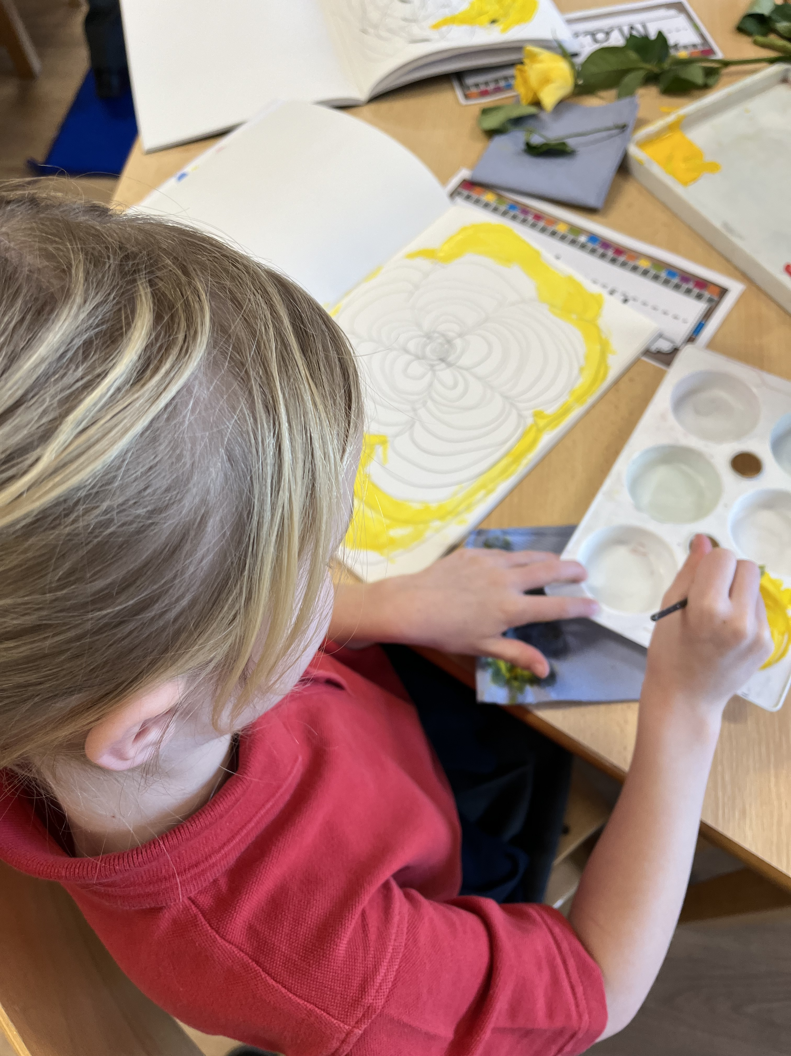

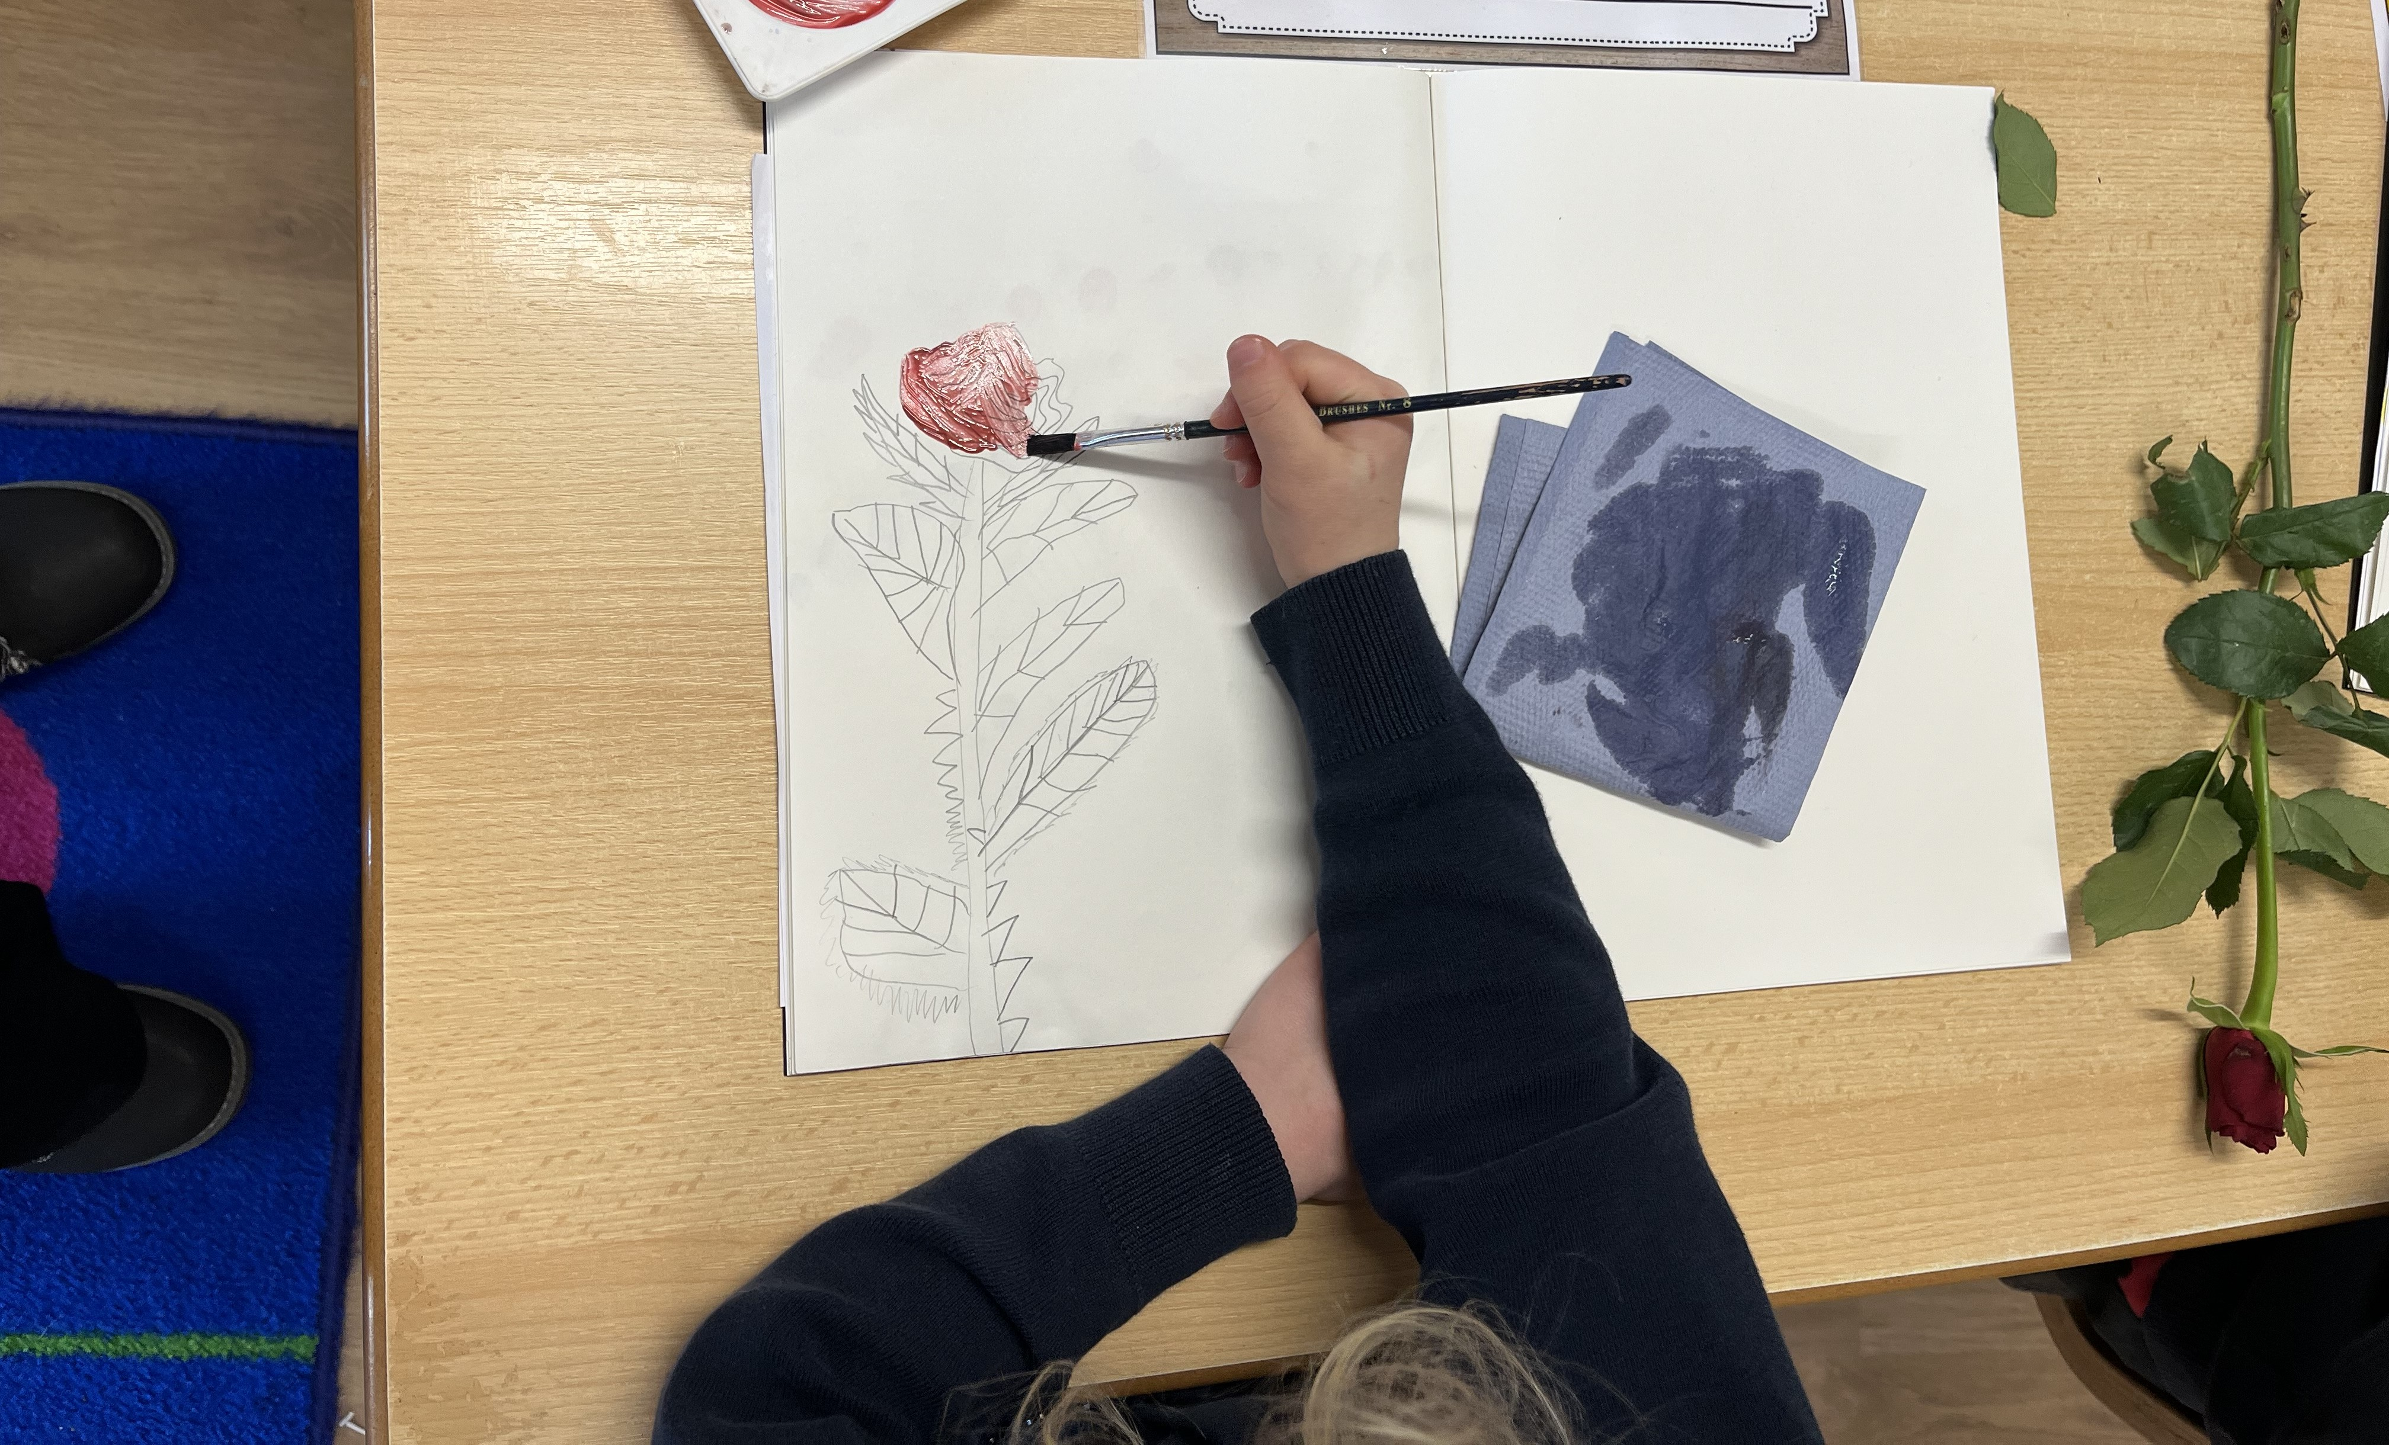

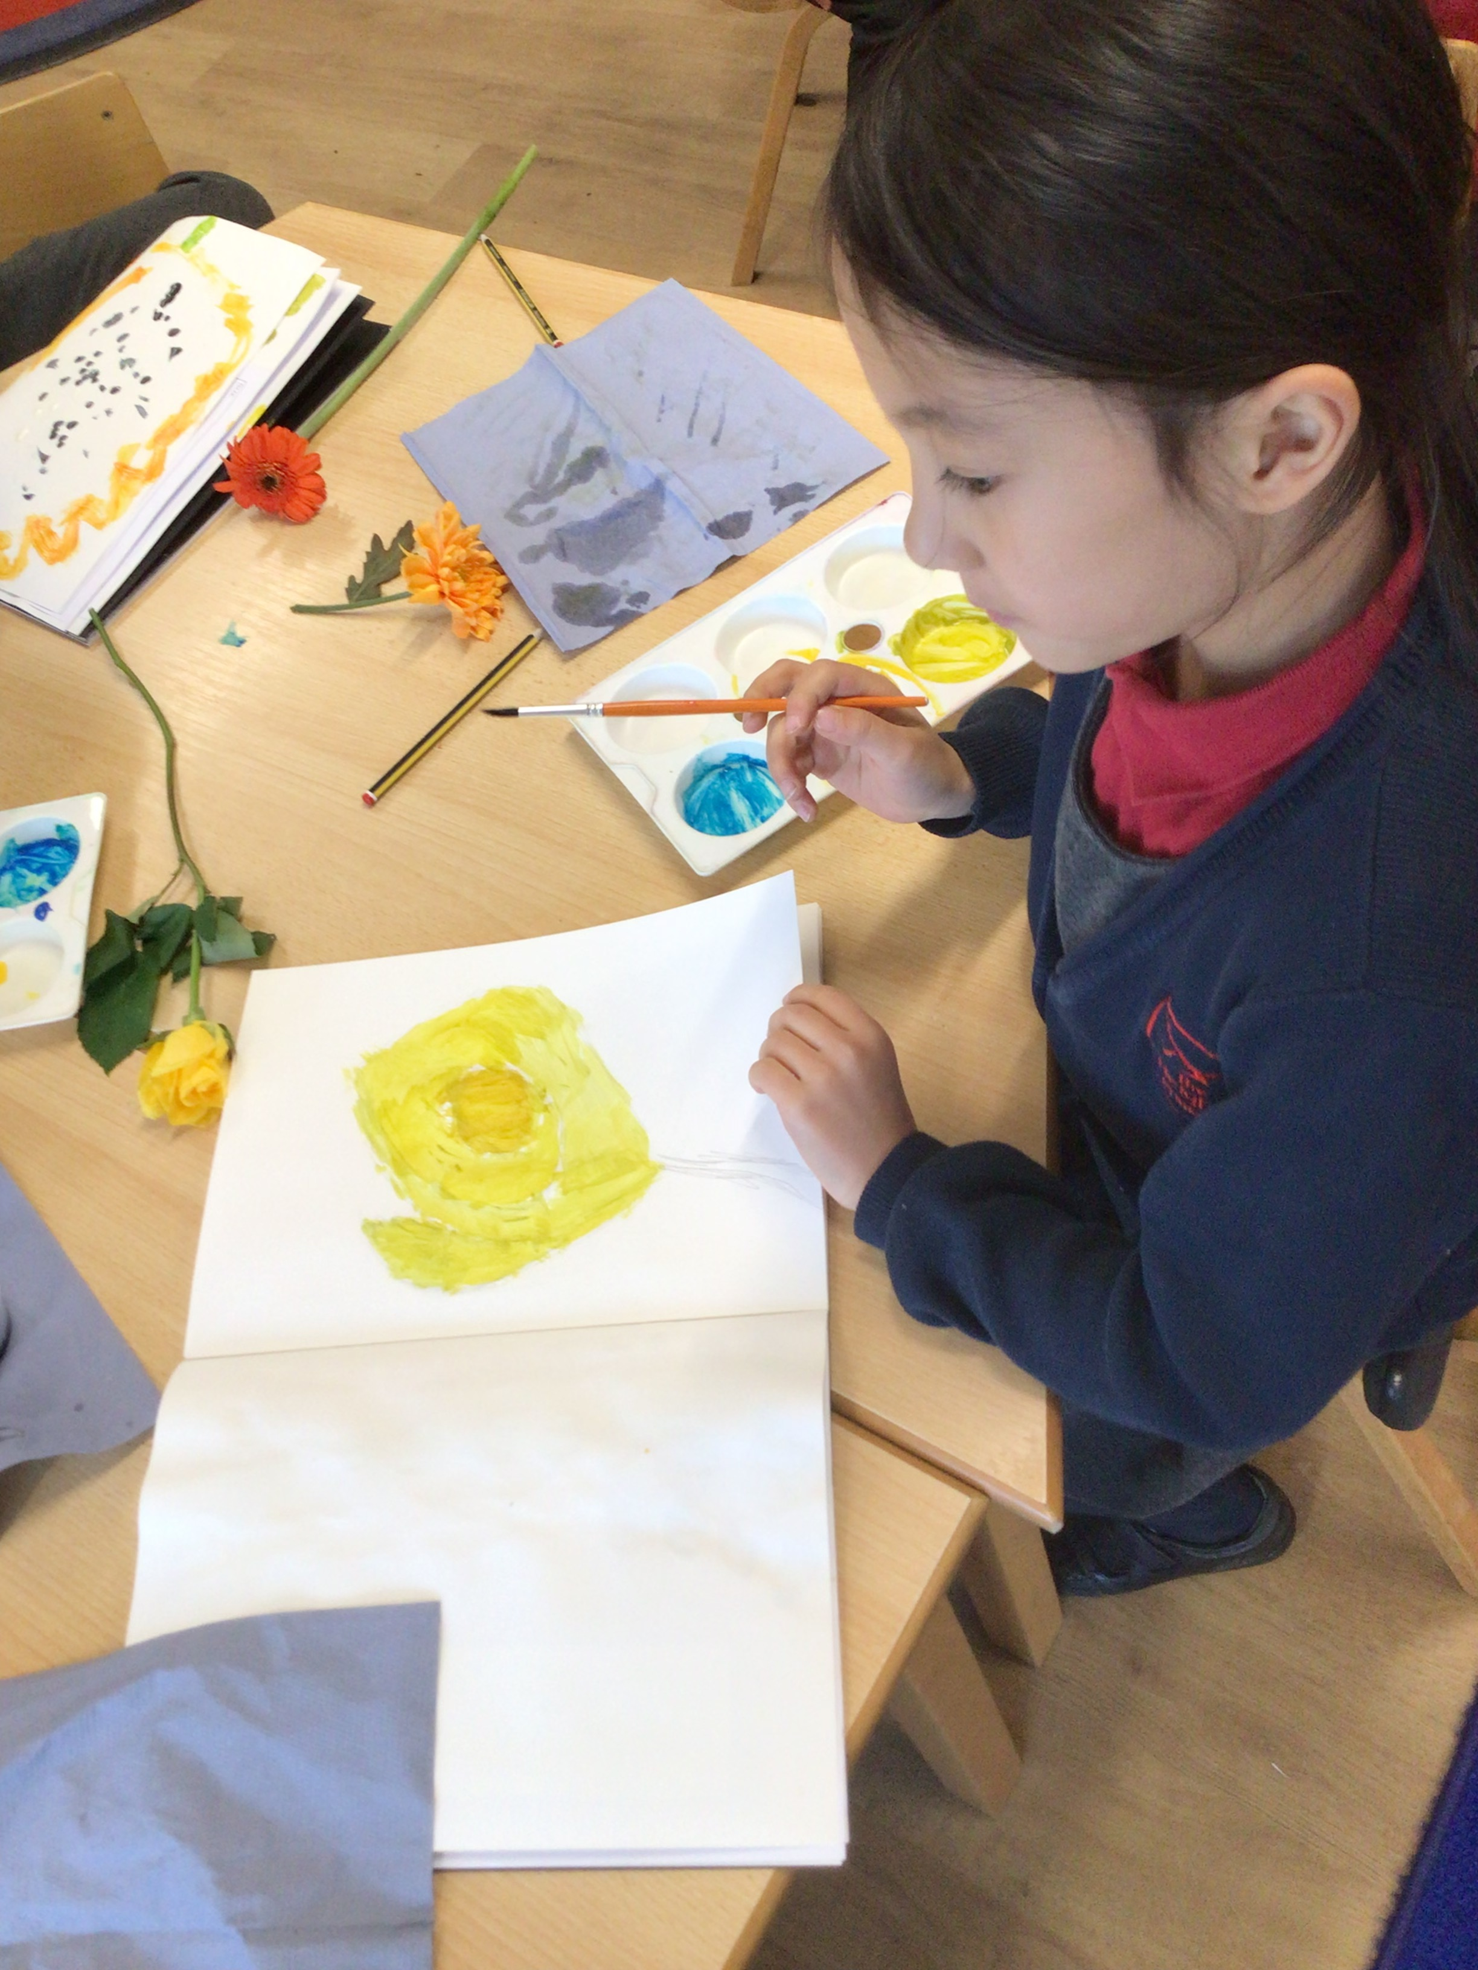

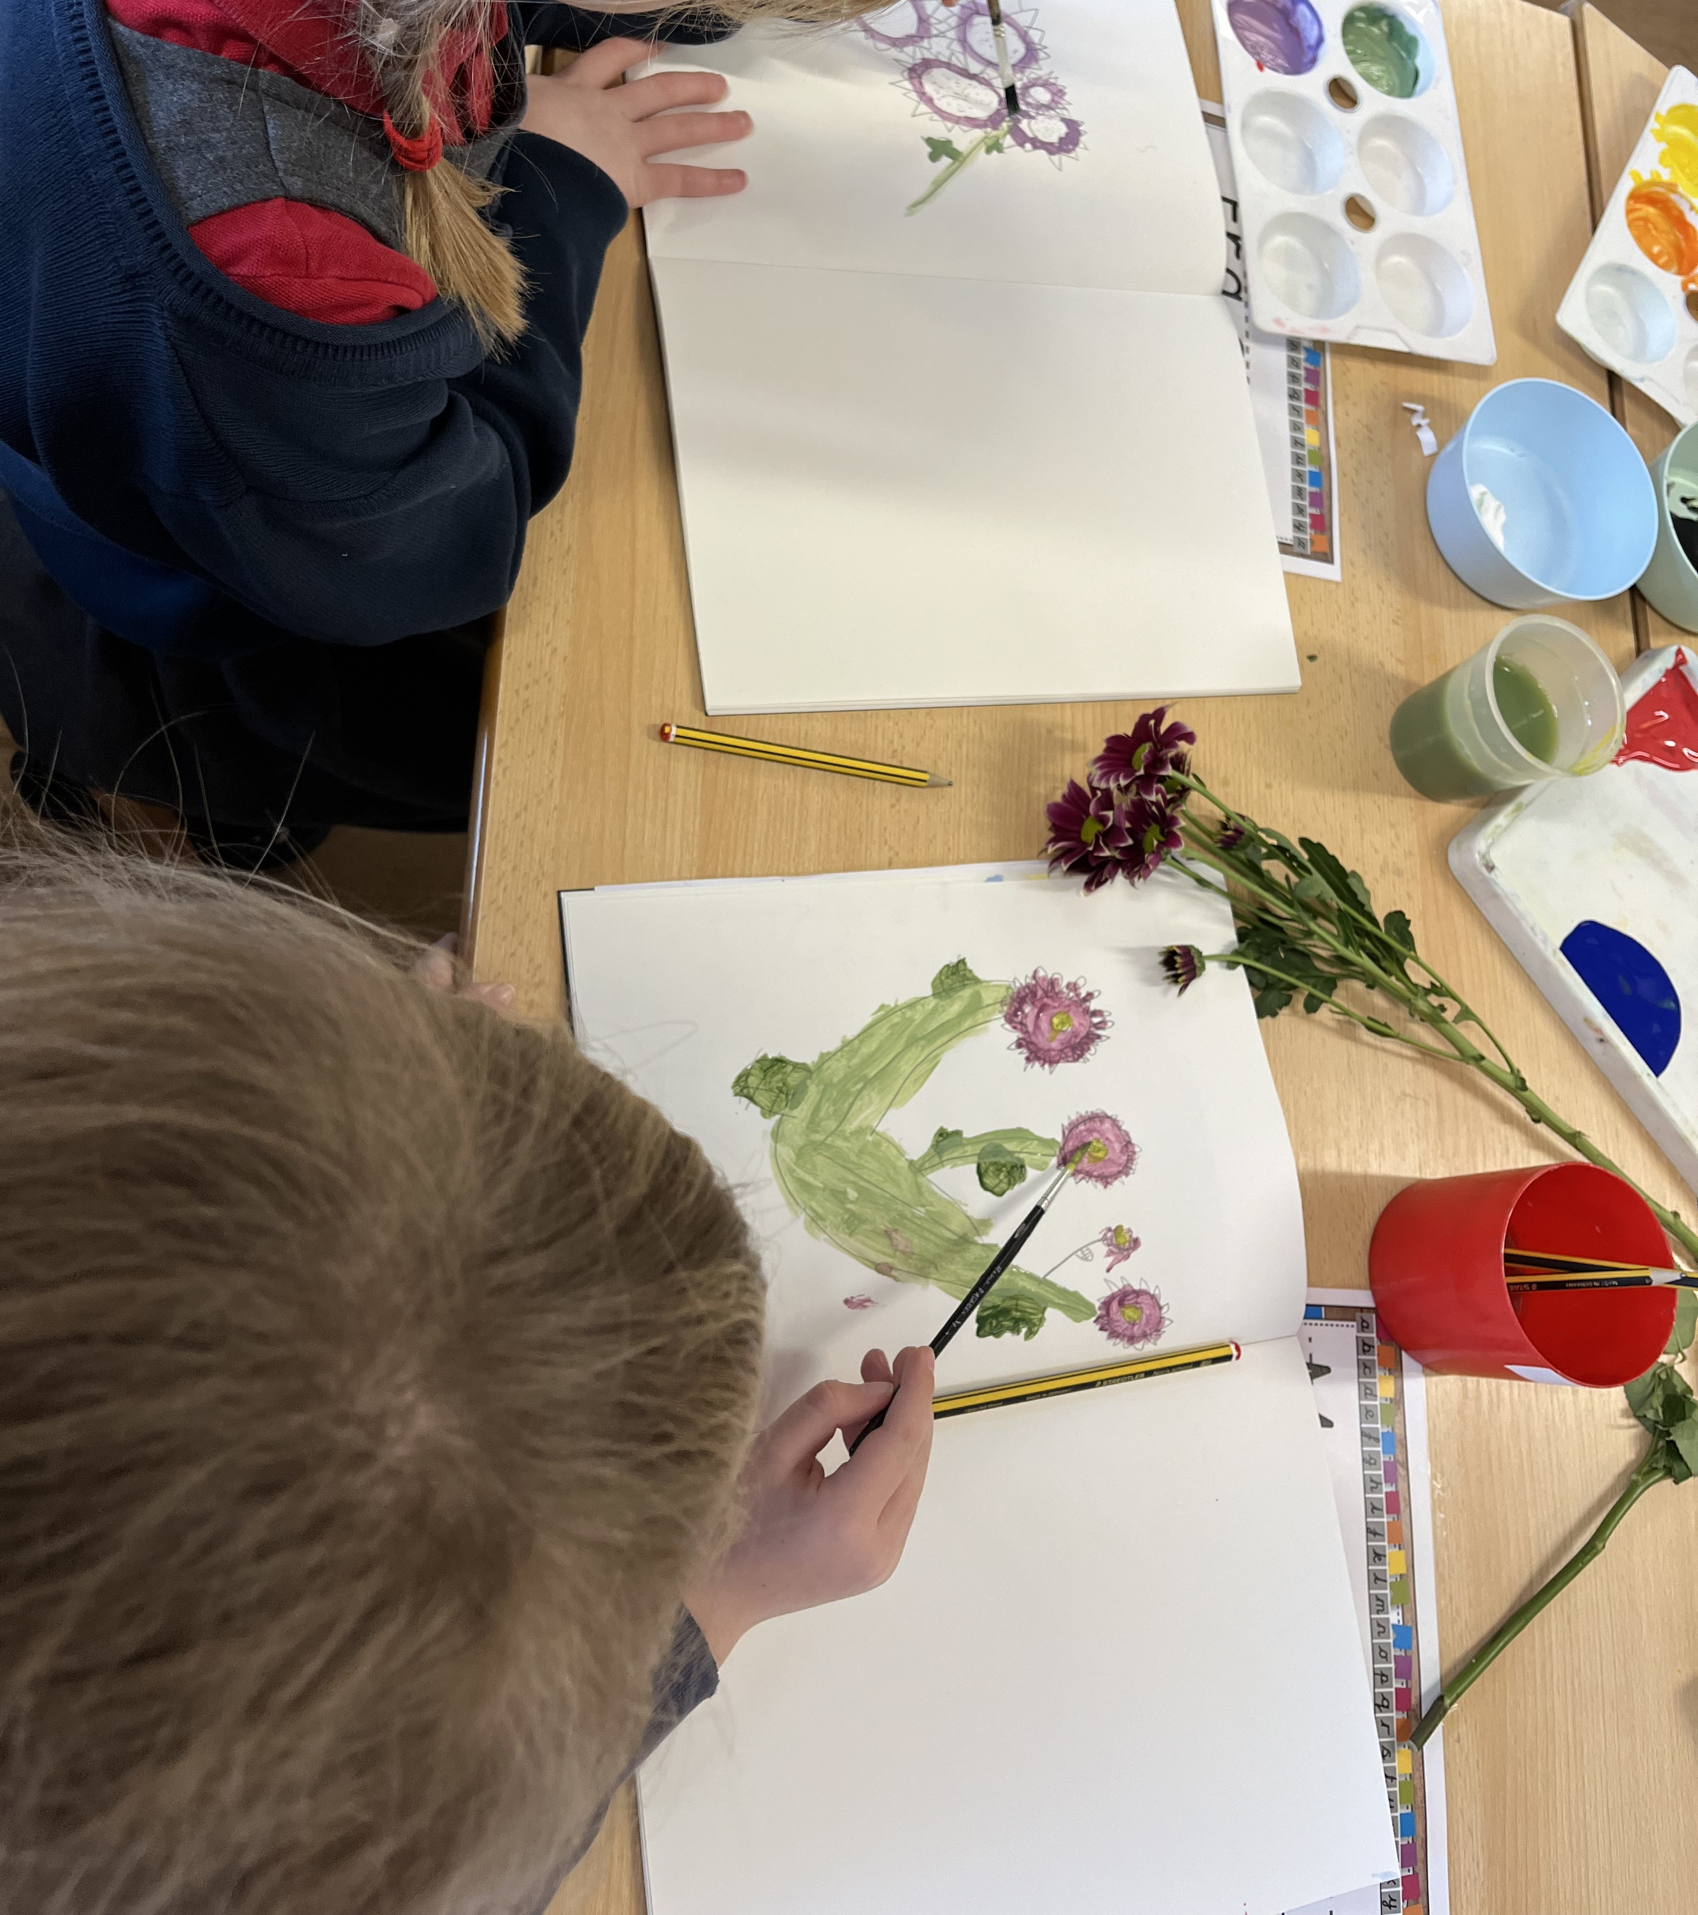

Year 2
In Maths this week, we have been continuing to learn about money and challenging ourselves to add and subtract amounts where it requires us to ‘bridge the tens’, eg 27p + 46p.We’ve been working with a partner to analyse our food journals and after discussing the ways in which they are healthy, we made suggestions on what could be improved. In our topic work, we learnt all about the journey of Chocolate, from bean to bar and then had fun creating drama presentations to illustrate the process. We also had a visit from Professor Draymond. He works at Reading University, where they are trying to cultivate cacao trees and he talked to us and showed us some of these amazing plants.
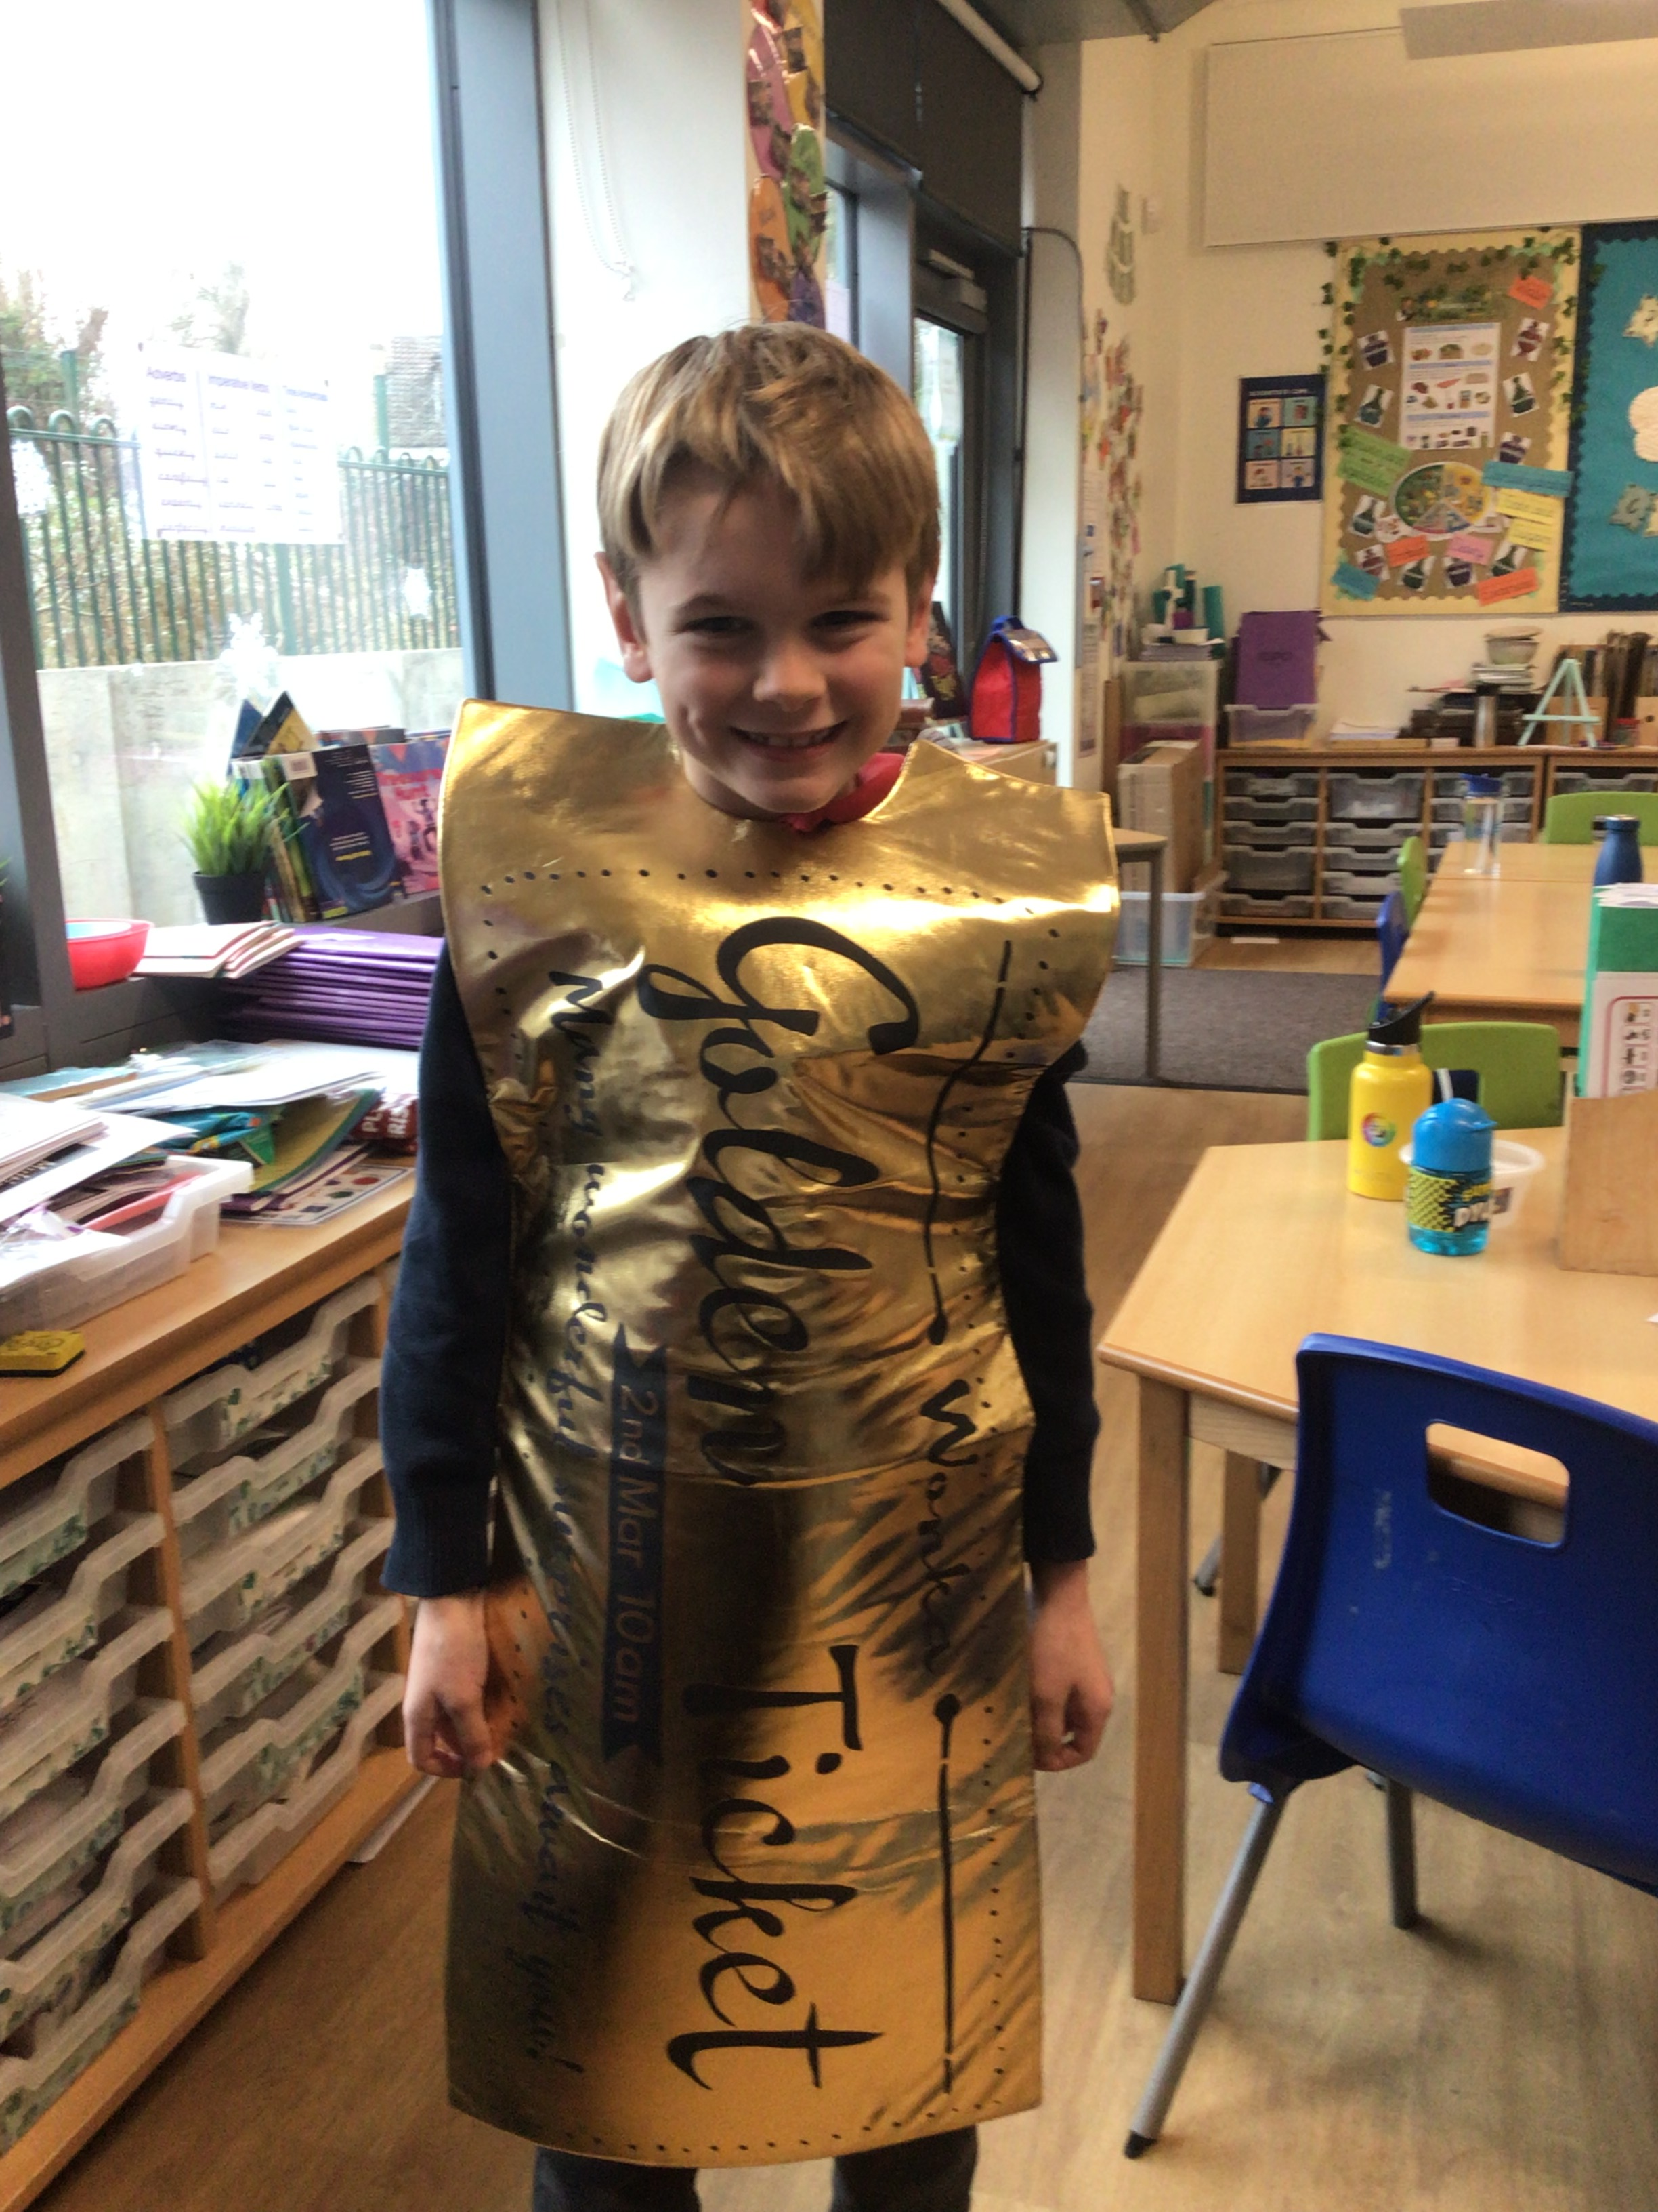

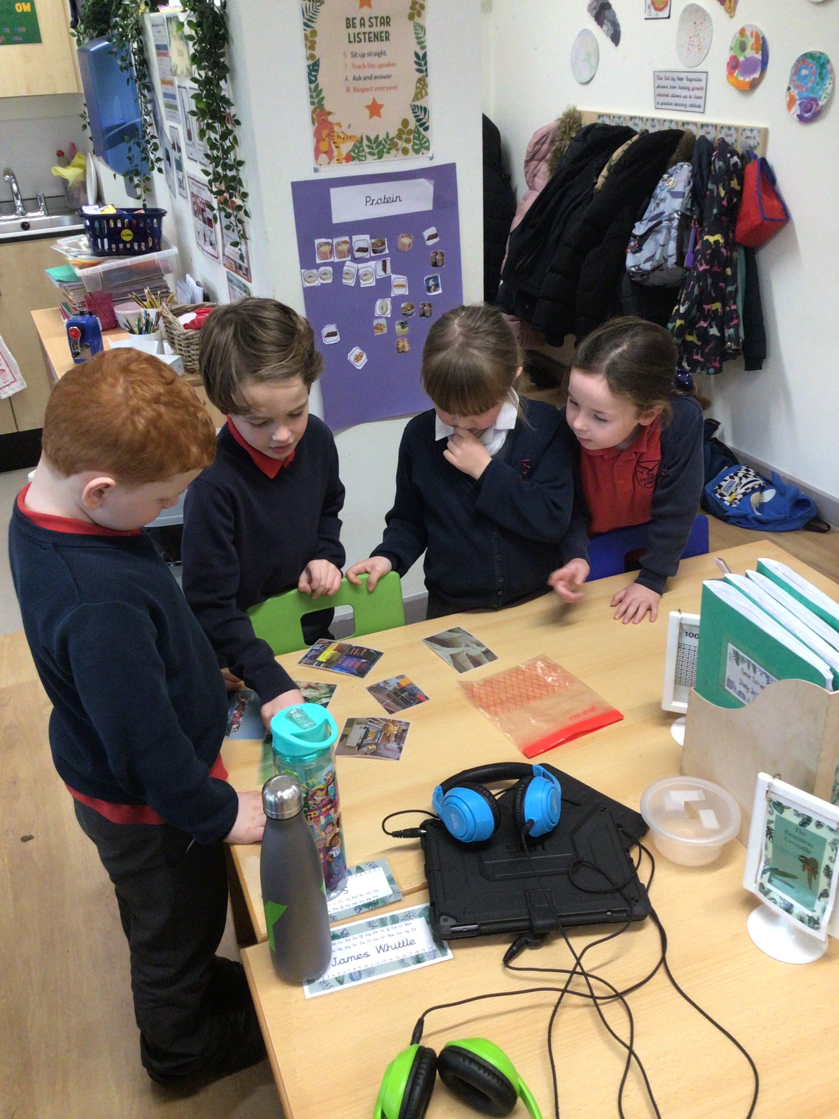

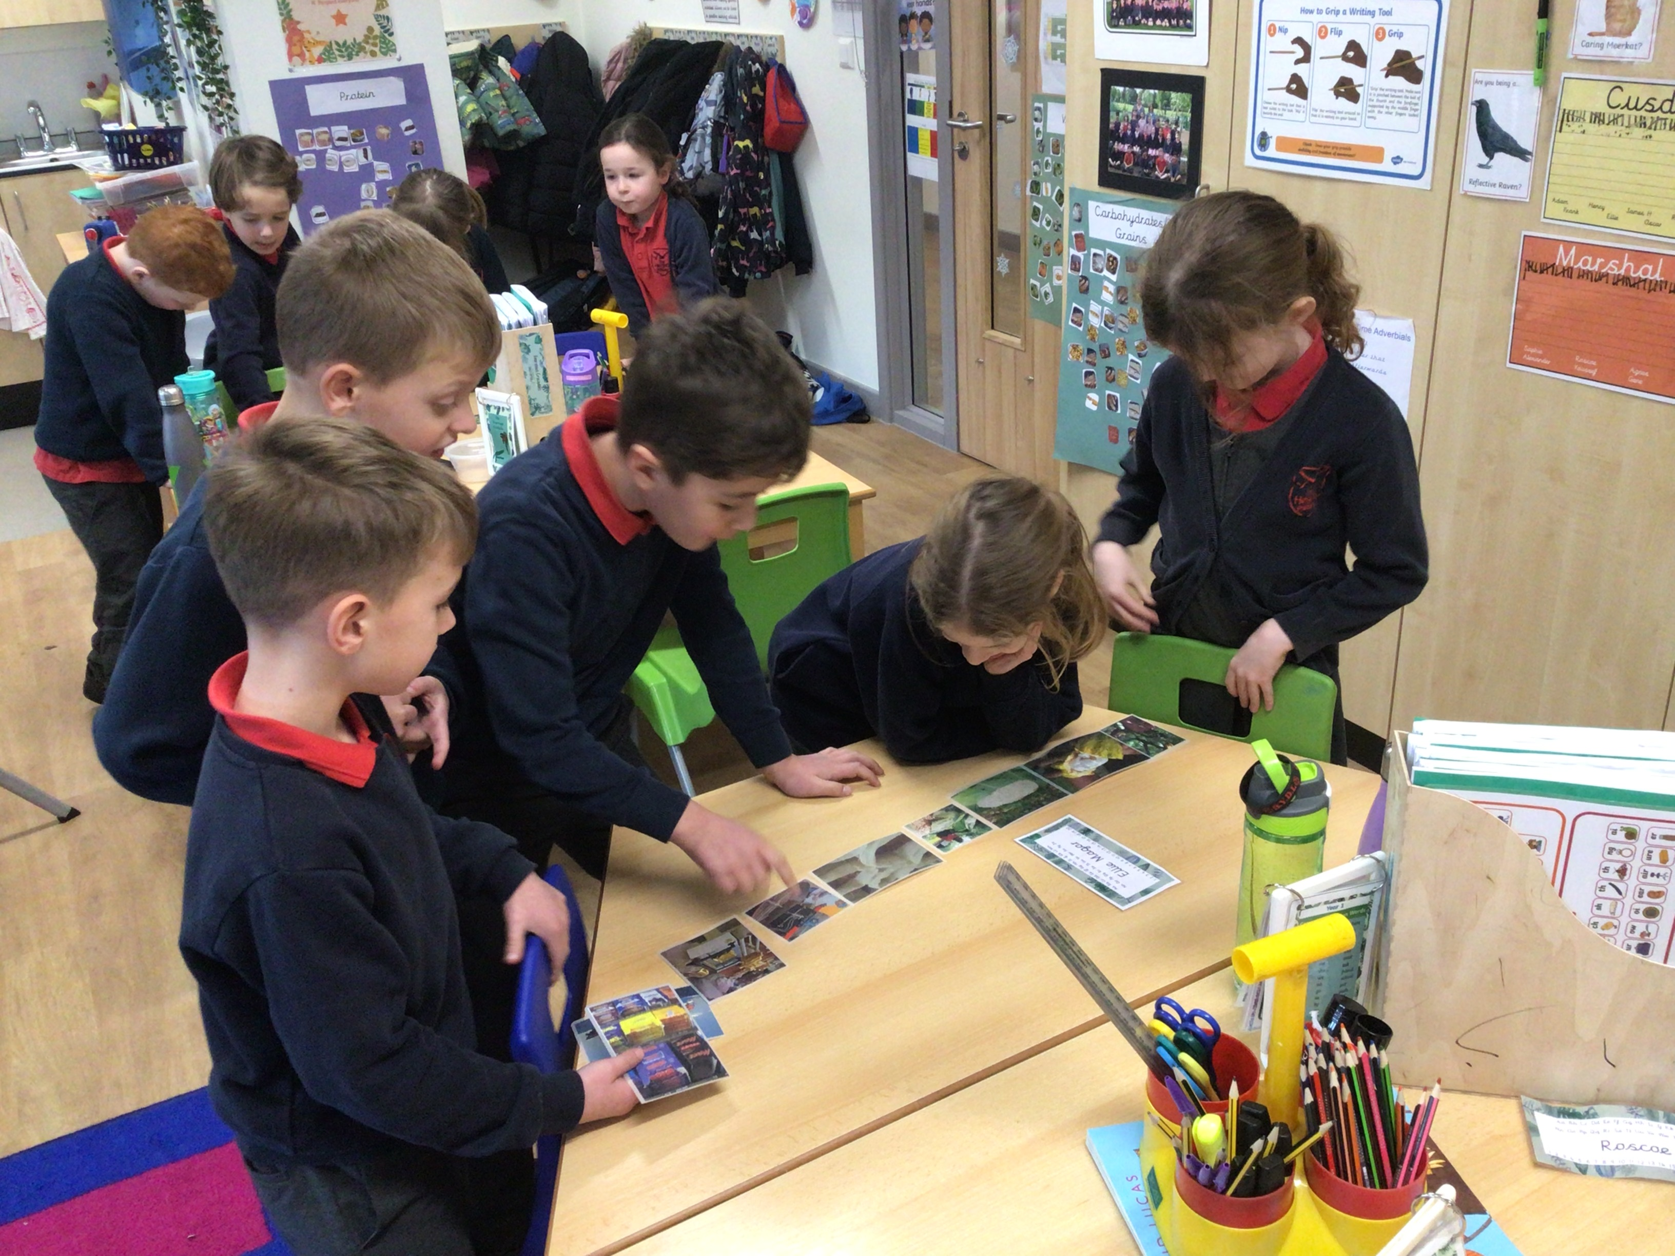

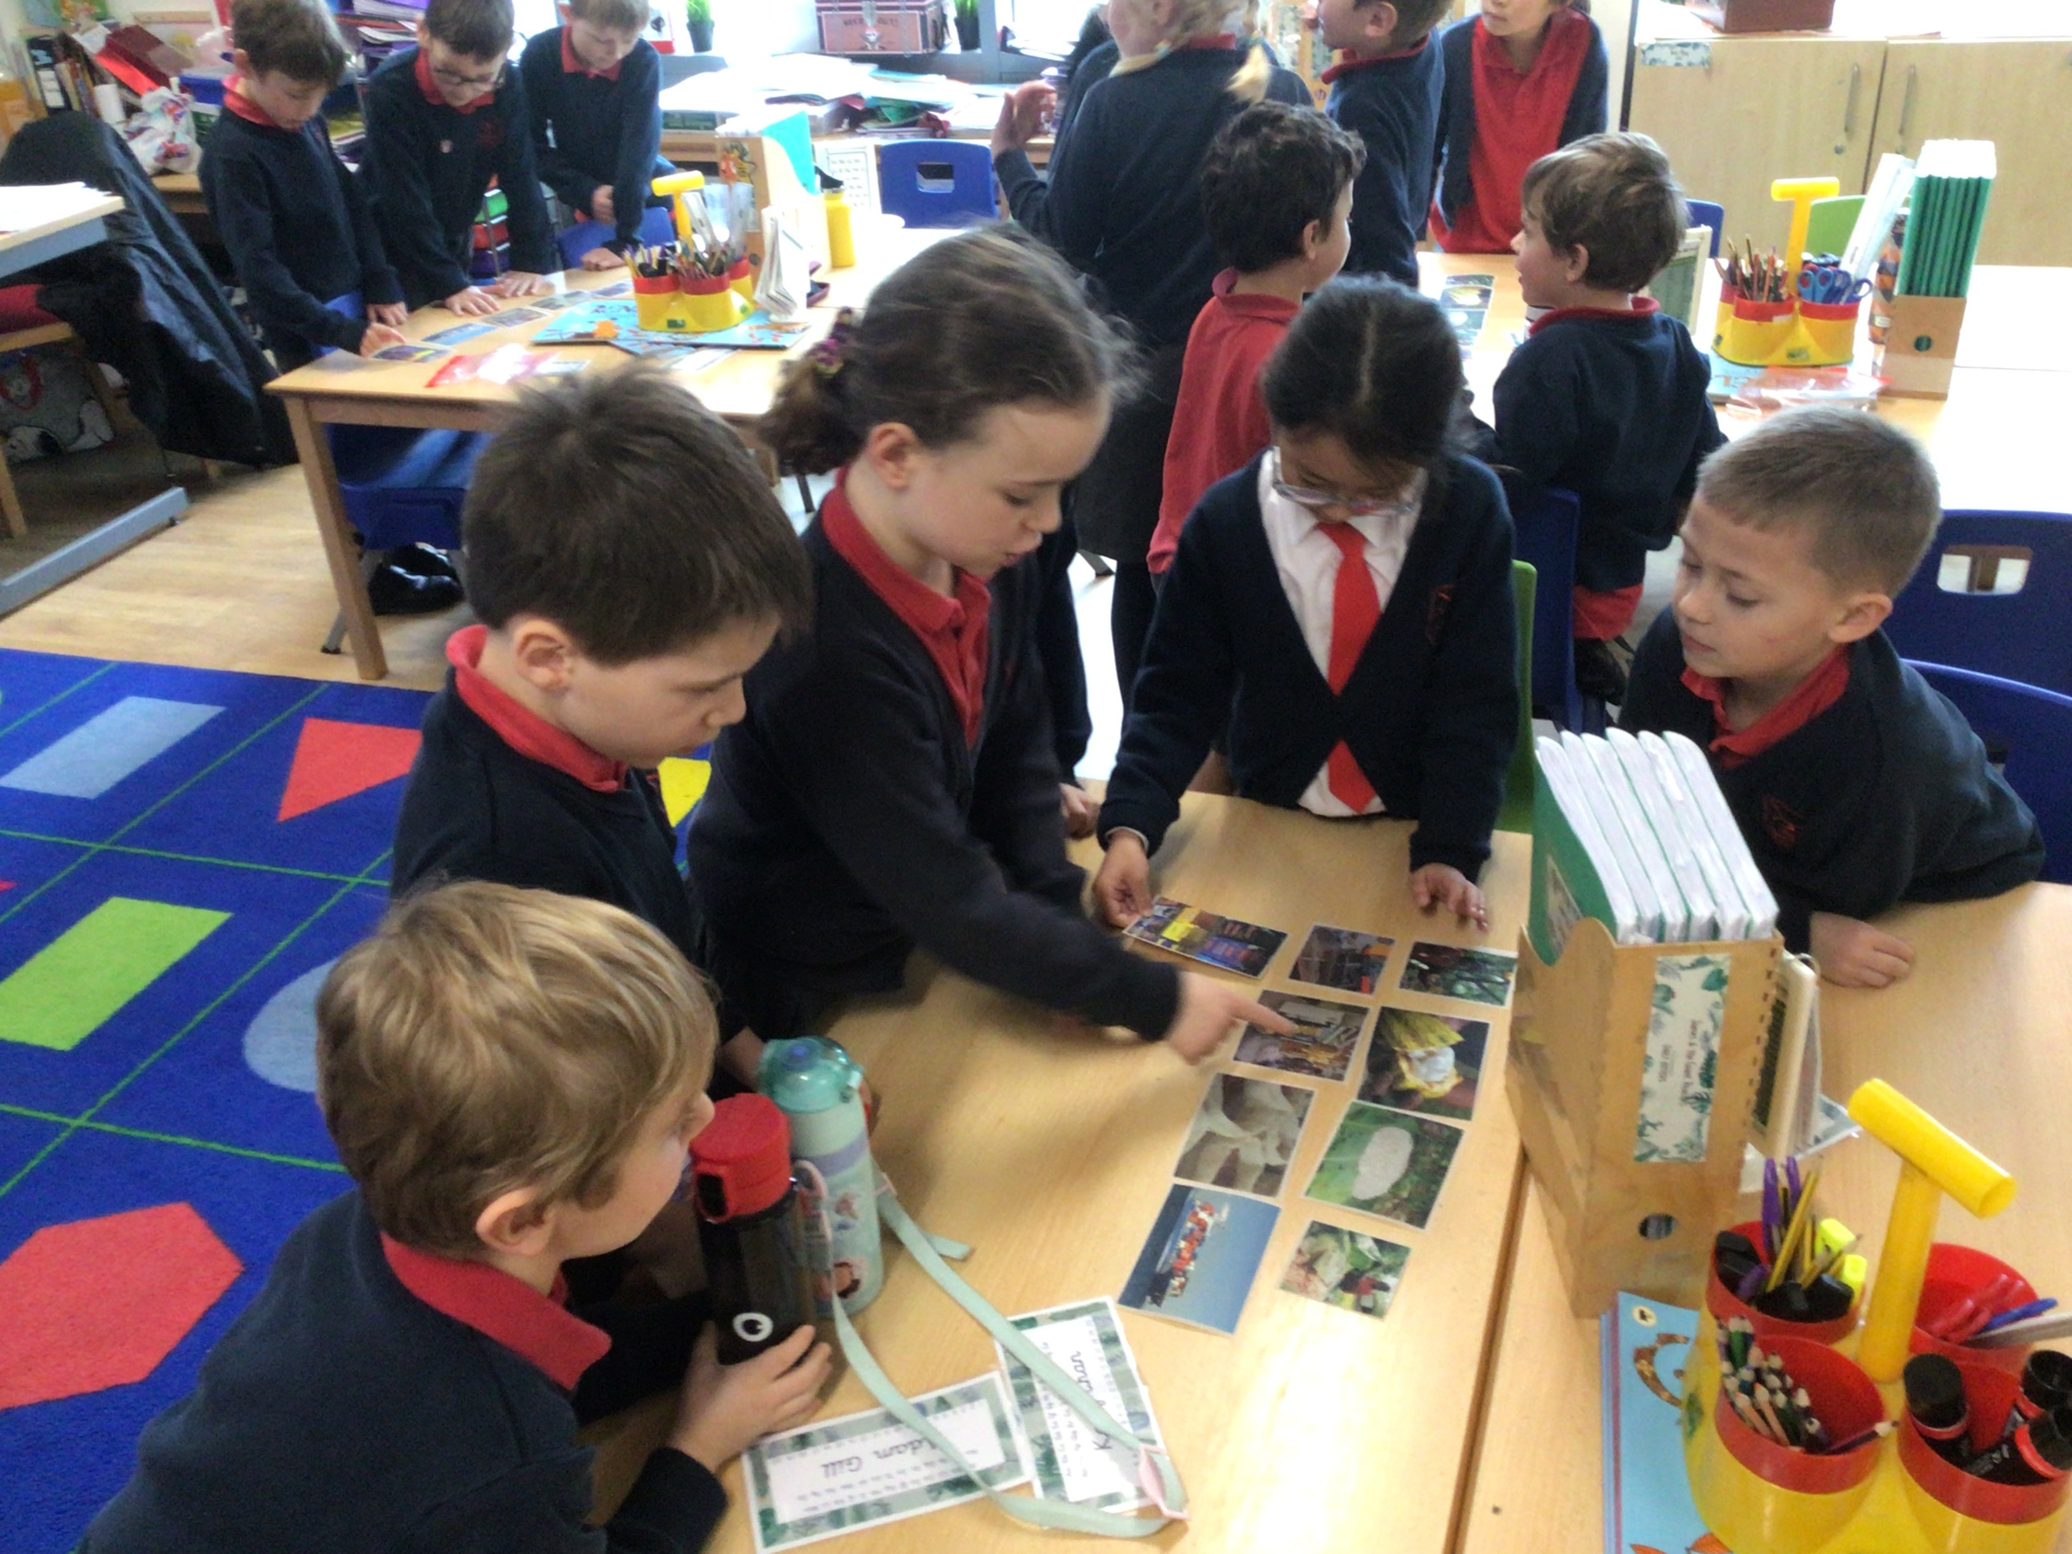

Year 3
We finished and published our Stone Age Boy stories this week and then created a class book for us all to enjoy. We’ve been adding and subtracting pairs of 3 digit numbers using the compound method in Maths and in Science we’ve been investigating how a shadow is made and how we can increase and de crease the size of a shadow. We have also had fun exploring different types of cave art and then using chalks and charcoals to create our own.

Year 4
As part of our topic of ‘States of Matter’ in Science we have been investigating how water evaporates. We planned an experiment to see where washing would dry the quickest and how long it would take to dry. We’ve been learning how to spell words with a plural possessive apostrophe in our spelling lessons and how to answer inference questions in guided reading. We’re enjoying the questions we’ve been asked to discuss at home to help improve our oracy skills. This weeks was: ‘Would you rather be a Roman soldier or a Caledonian tribesman?’ In Maths we have started our topic of division by learning how to divide a 2-digit number by a 1-digit number.

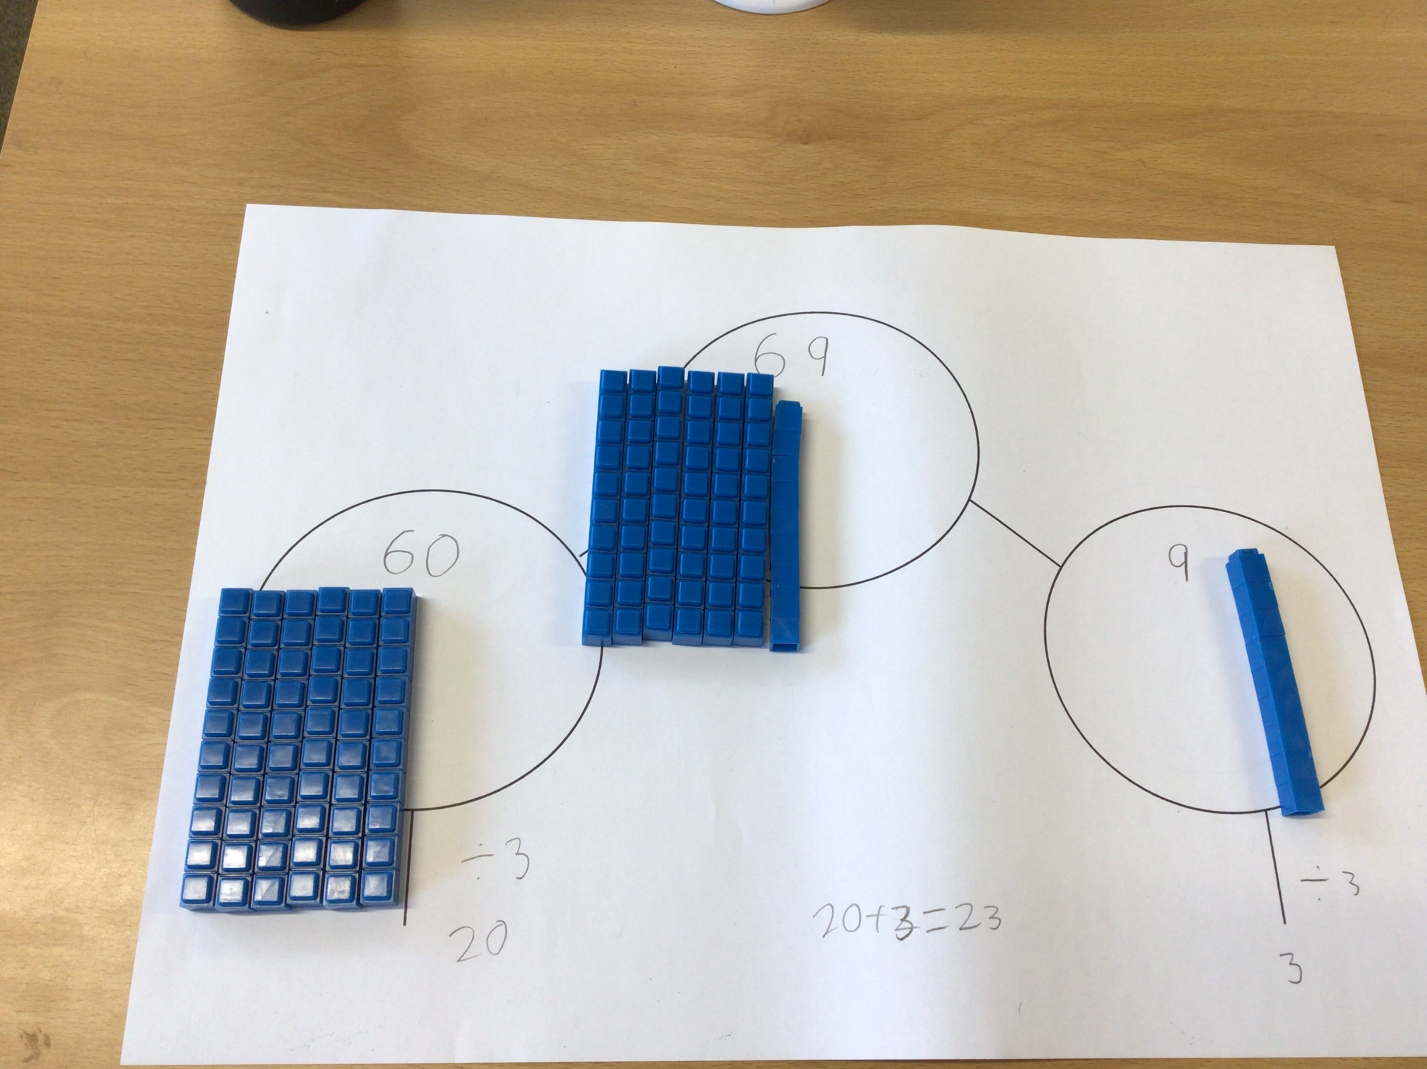

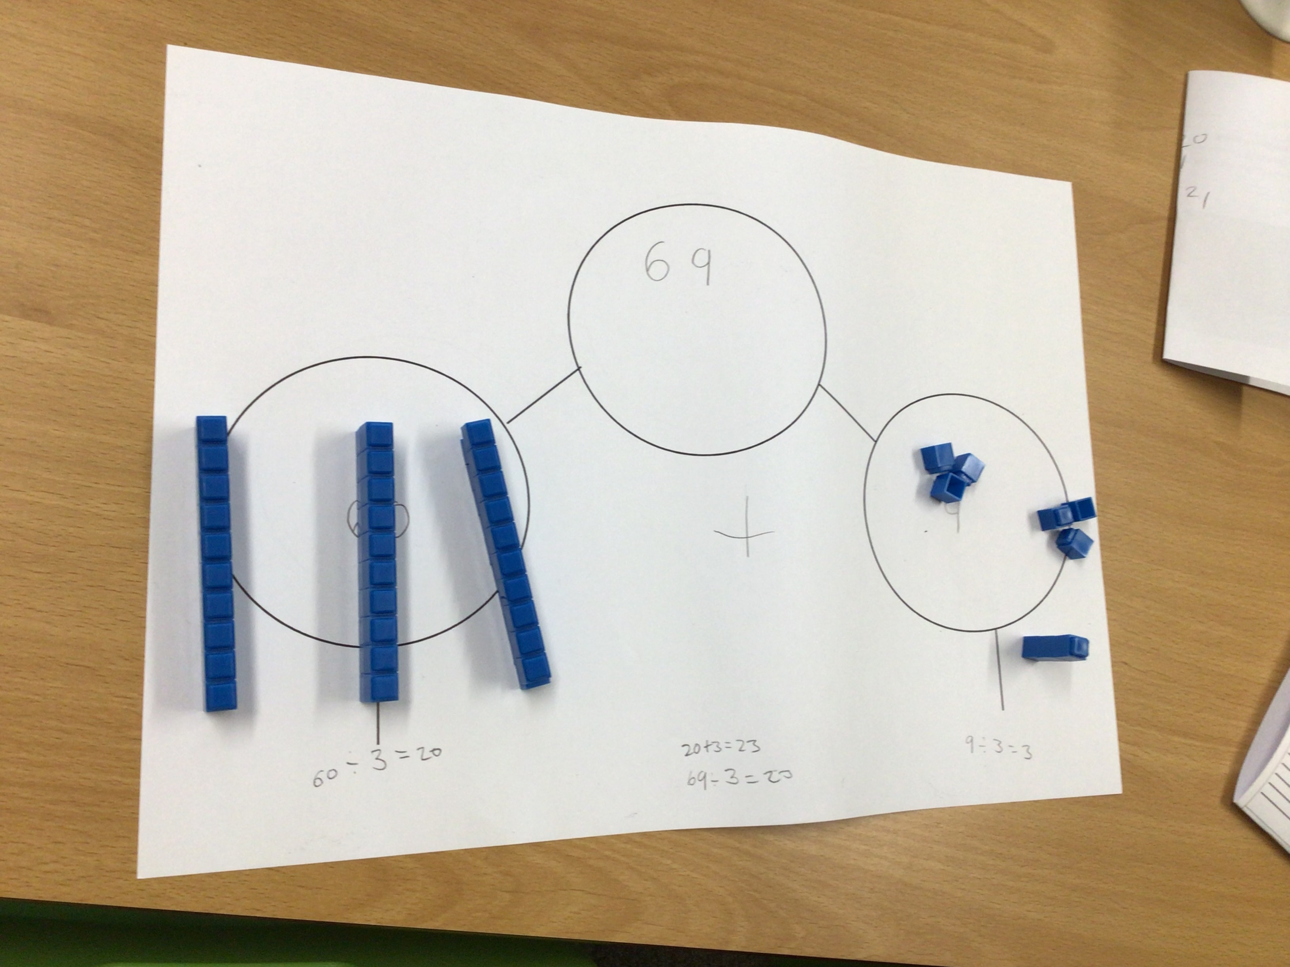

Year 5
We’ve also been busy in our Science lesson this week and have been trying to explain the effects of water resistance on moving objects. We’re really enjoying our study of Gustav Holt’s ‘The Planets’ in Music and have started to compose our own science fiction theme using glockenspiels. We’ve been using four or six figure grid references to locate places on a map in Geography and have been multiplying fractions by whole integers and finding fractions of amounts in Maths.

Year 6
We have started to explore the conventions of narrative through the story telling of fables. We’ve been listening to and watching different versions of Aesop’s Fables and Rudyard Kipling’s Just So stories in order to help us create an up-levelled version or original fable of our own. We’ve been focussing on algebra in Maths and developing our understanding of block coding, loop coding and repetition of instructions in Computing. Science has also been really fun, as we’ve been learning about Sir Isaac Newton, the theory of colour, light waves and the colour spectrum.

Safer Internet Day
Please click on the link below to read more about Safer Internet Day.
Safer Internet Day

Late Drop off Items
Please can we urge parents to help their child pack all the things they need for their school day to avoid the large number of late items which are dropped off daily. This is to minimise disruption to the classrooms and children missing out on valuable lesson time.
In the event you do need to drop off a late item, please do inform a member of staff in the office. Every effort is made to ensure that the forgotten item reaches the class, however we cannot guarantee this due to the busy nature of the school.
For forgotten items that are for an afterschool club, please ensure you make the club provider aware of this.

Caversham AFC – Semi Finals weekend
We would like to wish good luck to the below teams who have all done incredibly well this season in reaching their respective BYDL (Berkshire Youth Development League) cup semi-final games due to be played this Saturday. All 3 x teams, Caversham AFC Titans, Krakens and Sparrow hawks have players from the Heights primary across years 5 and 6.

Twitter
Please follow @AtHeadteacher for updates
Please follow @TheHeightsArts for updates

Dates for the Diary
Safer Internet Day | 6th February
Half Term | 9th February
World Thinking Day – Brownies & Cubs wear their uniform | 22nd February
Year 2 Chocolate Workshop | 26th February
Year 3 Tag Rugby Festival | 29th February
Year 4 Roman workshop | 19th March
Reception - performance to parents | 27th March
Easter Holidays | 28th March (1:30pm finish)

I hope you all have a lovely weekend.

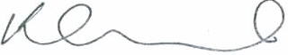
Mrs Edwards

