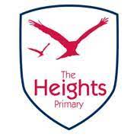
We warmly welcome families to our final SEND coffee morning of this academic year.

Wednesday 7th June from 9am-11am
at The Heights Primary School.

Making Sense of Autism
with Jenna Redmond
(Autism Advisor for Reading).

We hope to see you there.
Kind regards,
The SENCo team

